October 21, 2019 – Binaakewe-Giizis(Falling leaves moon

Volume 8 Issue 4
Oshki Ogimaag 73 Upper Rd, PO Box 320

Upcoming Events
October 31st- Halloween Parade at 1:00 in the Gym. (Students will put their costumes on after lunch). Classroom parties are after the parade.
Our Annual report will be posted on the website by the end of October.
November 1- No School for students- End of 1st Quarter.
LUNCH MENU
( October 21st – 31st, 2019

Monday – beef stew, corn bread, peaches, v8-juice
Tuesday – spaghetti, carrots, garlic bread, pineapple
Wednesday – ham, cheesy potatoes, broccoli, mixed fruit
Thursday – pizza, salad, pears
Friday – indian taco’s, fruit salad, corn

Monday – corndogs, tater tots, beans mixed fruit
Tuesday – chilli, grilled cheese, carrots, oranges, crackers
Wednesday – French toast, sausage, applesauce, juice
Thursday – chicken nuggets, seasoned rice, green beans, fruited jello

All meals come with bread & milk
OOCS menu can be found at oshkiogimaag.org

www.oshkiogimaag.org (218) 475-2112

Chi-Miigwech to the staff, students and volunteers that helped prepare, set up, speak at and clean up for our Fall Feast. We served some wonderful food to over 80 guests!

Students should be wearing their warm coats to school with hats and gloves- unless it is raining we still go outside every day and we go to Wabaan every Wednesday afternoon.

Kindergarten News- Ms. Jeana
The Kindergarten class has been busy preparing many dishes for the Indigenous Day Feast. We used apples that we harvested from Mineral Center and made apple sauce. The students used a machine to peel, core and slice the apples. They helped measure apple cider, lemon juice, cinnamon and sugar. They then put everything into the crockpot to cook all day. Kindergarten also made a cranberry sauce in a crockpot to drizzle over the top of a squash and apple granola dish that was put together in the Kindergarten room. Tess taught a lesson about white flour and wheat flour. They learned how to make bread with four ingredients; they put all the ingredients into a Ziplock bag and shook it up to make the dough. We let the dough rise and then we baked it in the oven. The bread was sliced and served at the feast along with the crabapple jelly our class made with Bonita! It was Fire Safety week and our class was able to see and explore a firetruck. They took turns sitting in the truck and putting the sirens on so they could hear the sound. Our students were also gifted with goody bags, which they loved! Thank you to all the firefighters who made this possible and Thanks for all that you do for our community and keeping it safe. Happy Birthday to Oliver October 14^{th ;} we celebrated with cupcakes!
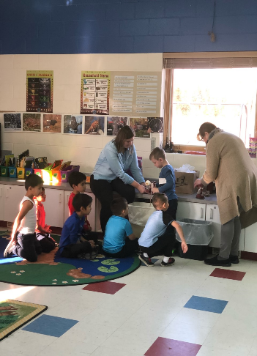
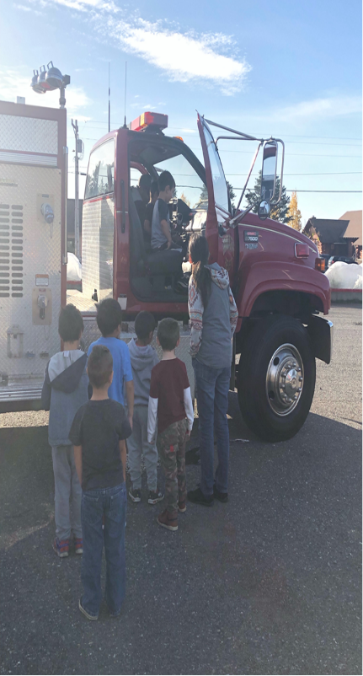
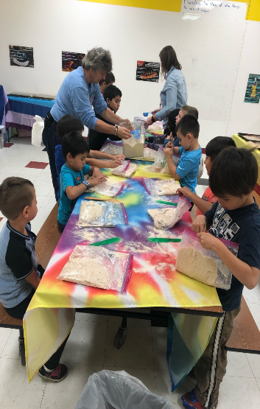

4-6 Grade – Mr. Brooks/ Ms Kat
In the 4-6 classroom, the students have been learning Roman Numerals. They have learned what they look like, how they combine together to make different numbers, and how to read/convert them. Learning Roman numerals is a great way to help children increase their number sense, better understand how numbers work, and particularly good for increasing mental math skills.
The students have also been learning the dramatic effects that water can have on the earth through fun classroom experiment about erosion. They packed sand into a shallow pan and then poured water onto the surface and then made observations on how dropping water can erode rock surfaces.
The students have been working very hard preparing everything for our annual feast, each dish included something that we harvested. Miigwech to those who donated food or brought a dish. A really big thank you to Ms. Bonita, the parent committee, and the student feast committee for all the planning and preparation they did!
Waaban has started out great also! The boys and girls have started to learn some basic survival skills by by starting to build their own lean-to shelter, using simple knots. They have also been working on forest maintenance by starting some early preparation tasks that need to be done for sugar bush. They also have started to become some young orienteers by learning basic compass skills.
Cultural liaison – Bonita Poitra
October has all been about planning and preparing for our Indigenous Peoples Day Feast. We gathered, looked at recipes, decided a menu and cooked! Our students made Jelly, Pickles, and Breads; we also had a tea tasting party to decide what teas to make. We made desserts and dishes that would showcase the items we harvested from Grand Portage and from our gitigaan. The night of our event was a success! We had over 80 people that attended and ate! We had a lot of compliments for the dishes that were made. Thank you to the students and staff of Oshki Ogimaag for all of your hard work! Thank you to all of those people who donated to our feast, we had donations of wild game, dishes and time. Thank you to the Parent Advisory Committee for set up and clean up!
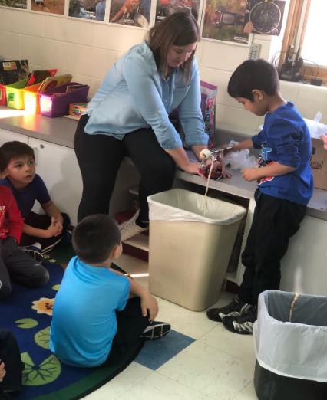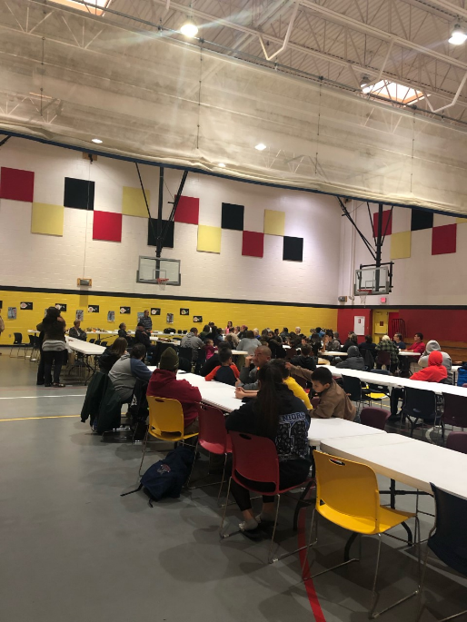
We have returned to Waaban and it has been a great place for us to teach and learn! This winter we will be using the Phenology information and creating a winter count. I learned about the Lakota winter count when I was a child, and would love to start this project using the observations of the students, the predictions and really make this project informative and fun. I would also like to show our students that the Ojibwe kept records using birchbark scrolls.

