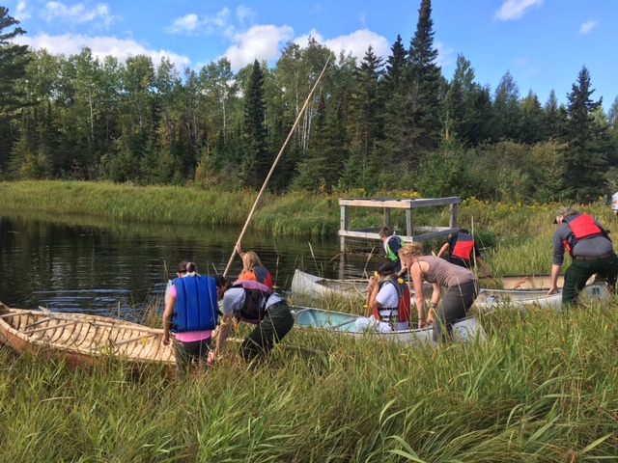

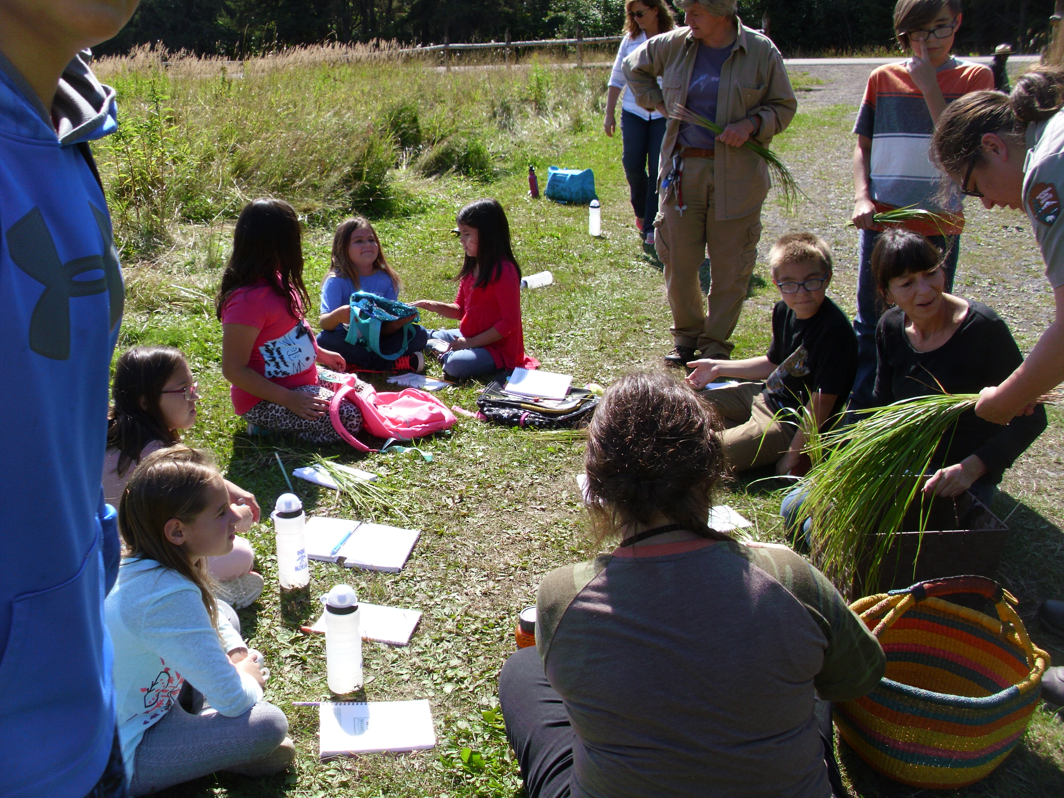

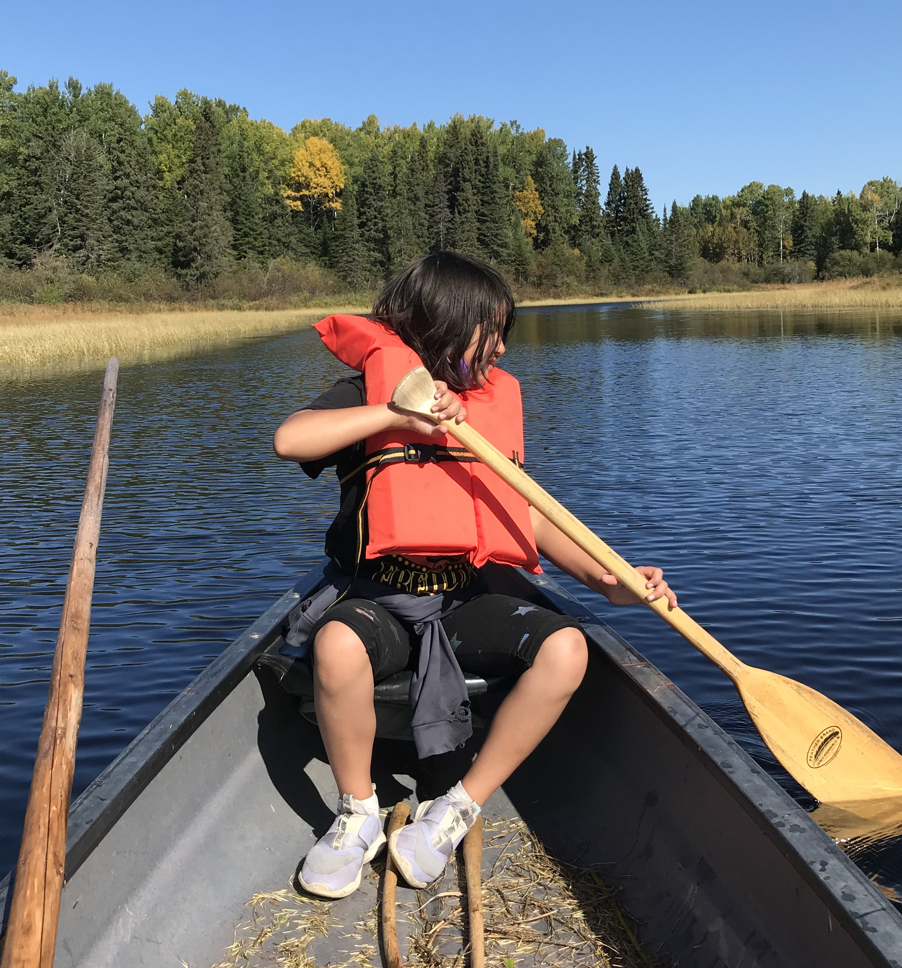

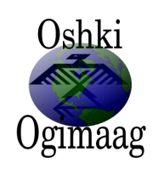

OSHKI OGIMAAG CHARTER SCHOOL

PUBLIC CHARTER SCHOOL DISTRICT #4195

SCHOOL YEAR 2019-2020
WORLD’S BEST WORKFORCE & ANNUAL REPORT
Table of Contents

- School Information – Page 3
- Implementation of Primary and Additional Statutory Purposes – Page 4
- Student Enrollment & Demographics – Page 4
- Student Attendance, Attrition & Mobility – Page 5
- Educational Approach and Curriculum – Page 7
- Innovative Practices & Implementation – Page 11
- Academic Performance: Goals & Benchmarks – Page 13
- Educational Effectiveness: Assessment & Evaluation – Page 22
- Student & Parent Satisfaction – Page 23
- Environmental Education – Page 23
- Governance and Management – Page 25
- Staffing – Page 29
- Operational Performance – Page 32
- Finances – Page 33
- Future Plans – Page 34
- Distance Learning Plan Description and Reflection on Implementation – Page 35
- FASTBridge Benchmarks- Page 37

1. School Information

Contact Information
PO Box 320 73 Upper Road Grand Portage, MN 55605
218-475-2112
director@oshkiogimaag.org
oshkiogimaag.org

Grades Served YEAR OPENED
Kindergarten-6th grade 2009

Mission and Vision
Oshki Ogimaag Community School’s (OOCS) mission is to create a K-6 learning environment of excellence based on traditional teachings. Rooted in the Anishinaabe culture and language within a technological setting we will prepare students through hands on, community based projects to become lifelong learners that reach their personal and academic potential; preserve the Anishinaabe language and culture; and contribute to the wellness of future generations.
Our vision is to guarantee the future of Anishinaabemowin, cultural knowledge, values, and history to sustain and empower our Elders, family, and youth. Upon graduation students will have academic competence, positive leadership skills, and social self-sufficiency. Collaboration with tribal schools worldwide will promote knowledge and respect for Indigenous worldviews, and allow for meeting the ever-changing educational and social needs of the Grand Portage Community with new methodologies and innovative technological opportunities. Parents, students, teachers, and administrators become allies in education promoting student ownership of learning through empowerment and recognition of diverse learning styles

Authorizer Information
Osprey Wild serves as the authorizer of OOCS, and has since opening in 2009. OOCS and Osprey Wild have a current contact through the FY21.

The authorizing mission of Osprey Wilds is to ensure quality academic and environmental literacy outcomes for students in Minnesota by conducting effective oversight and evaluation of its authorized schools, providing strategic support to schools, and making informed and merit-based decisions about its portfolio of charter schools.

The authorizing vision of Osprey Wilds is to authorize a portfolio of high performing charter schools that instill a connection and commitment to the environment in their school communities, while working towards a healthy planet where all people live in balance with the Earth.

Erin Anderson, Director of Charter School Authorizing
Osprey Wilds Environmental Learning Center
Charter School Division
1730 New Brighton Blvd
Suite 104, PMB 196
Minneapolis, MN 55413
(612) 331-4181
www.auduboncharterschools.org

2. Implementation of Primary and Additional Statutory Purposes

The primary purpose of Oshki Ogimaag Charter School is to improve pupil learning and student achievement. The school will utilize Anishinaabe language and culture, social and emotional supportive strategies, and student projects in all academic areas to provide a culturally rich and engaging environment in which students can thrive academically.
The additional purpose of Oshki Ogimaag Charter to school is to encourage the use of different and innovative teaching methods. OOCS ensures that all students are provided the opportunity to learn through integration. Teachers will integrate the Anishinaabe language and culture, environmental education, and personal development in all academic areas.
Students learn in multi-grade classrooms and interact regularly with local elders and professionals in order to balance the rich history of the community with local culture and skills necessary for future success. Students are provided with learning materials that are relevant to them, learn problem solving skills through analyzing local issues, and learn about professional opportunities within the community. Social and emotional education are taught by using language, culture, and art. All academic areas integrate environmental stewardship and local knowledge. Strong community partnerships provide opportunities including: weekly classroom or field work opportunities, school garden project, and reading with elders/reading buddies program.
Along with innovative teaching methods, OOCS employs innovate assessment in addition to state testing and nationally normed Fastbridge tests. Quarterly exhibitions of learning demonstrate student understanding, engage community, and promote students’ ownership in education.

3. Student Enrollment & Demographics

STUDENT ENROLLMENT
Oshki Ogimaag School serves students living on and near the Grand Portage Anishinaabe Reservation. Students other enrollment options are enrolling in ISD #166 (Cook County Schools) in Grand Marais, MN; or Great Expectations Charter School (Grand Marais). Oshki Ogimaag is the only school located within 35 miles of the Grand Portage Reservation. In the 2019-20 school year, 100% of students were Grand Portage residents.
We are working to build a strong partnership between early childhood families and our school. The primary point of outreach will be the notification to parents and families that OOCS provides all services available to students in Grand Marais, a misconception which takes a targeted strategy to clarify. Focus needs to continue on retaining students as they reach upper elementary. Enrollment numbers are significantly affected by the following: Families leaving the community; families tend to send children to school together and as students graduate from the OOCS program, younger siblings go with them and many students want to participate in extra- curricular activities.

The 2020-21 SY we are starting off in an in-person learning model. Many of the schools across the state are participating in a distance learning model or hybrid model due covid-19. The administration and OOCS school board feel it is important to be able to offer in-person learning as much as possible to the Kindergarten-grade 6 students if households do not have health concerns that would keep those students at home in a distance learning model. Due to our community and county currently having zero active cases we are following all of the covid-19 guidelines that our school administration and school board has set in place in keeping our students and staff healthy and safe.

Number of Students Enrolled | 2018-19 | 2019-20 | 2020-21 (est.)
Kindergarten | 6 | 9 | 9
1st Grade | 3 | 3 | 7
2nd Grade | 0 | 3 | 5
3rd Grade | 6 | 0 | 3
4th Grade | 5 | 3 | 1
5th Grade | 2 | 3 | 3
6th Grade | 3 | 1 | 3
Total | 25 | 22 | 31
Total ADM (Average Daily Membership) for year | 20.32 | 21.73
STUDENT DEMOGRAPHICS

Demographic Trends | 2018-19 | 2019-20 | 2020-21 (est.)
Total Enrollment | 25 | 22 | 31
Male | 13 | 15 | 18
Female | 12 | 7 | 13
Special Education | 11 | 9 | 11
English Learners | 0 | 0 | 0
Free/Reduced Priced Lunch | 22 | 18 | 21
Black, not of Hispanic Origin | 0 | 0 | 0
Hispanic/Latino | 0 | 1 | 1
Asian/Pacific Islander | 0 | 0 | 0
American Indian/Alaskan Native | 24 | 22 | 29
White, not of Hispanic Origin | 1 | 0 | 2

4. Student Attendance, Attrition & Mobility

STUDENT ATTENDANCE
Student attendance continues to be a challenge for us. We work with individual families to improve their children’s attendance; some families are more receptive to our offered help than others. Ways we have tried to help is by offering rides to students if they miss the bus, make calls in the morning if the student does not arrive on the bus, keep breakfast hot until they get here, we give reminders about how important it is to be here every day.
Some reasons for our continued challenge may be; alcohol or drug abuse, parent’s trauma in the school system, lack of parenting skills, self-esteem in parents and/or the student.
We continue to look for resources to help with the attendance problem, we work closely as a team to see who has the best connection with the families that have attendance concerns.
We did meet the attendance goal, and plan to continue to work improve it even more.

 | 2017-18 | 2018-19 | 2019-20
Overall Student Attendance Rate | 87.36 | 88.32 | 90.87

STUDENT ATTRITION
Attrition rates have gone up a bit, some that left reported that it was so the students could join extra-curricular sports teams or for more intense Special Education Services. It is common to have students leave the community, and at times some will transfer mid-year.
Retention is an area that the Board of Directors has discussed at length and will continue to explore ways to retain students at OOCS.

Percentage of students* who were continuously enrolled between October 1 of the 2018-2019 school year and October 1 of the 2019-20 school year. | 70.5%
*Do not include graduating students or those who have completed your school program, i.e., if your school is K-6, do not include students who have completed 6th grade.

Percentage of students* who continued enrollment in the school from Spring 2019 to October 1, 2019. | 68%
*Do not include graduating students or those who have completed your school program, i.e., if your school is K-6, do not include students who have completed 6th grade.

STUDENT MOBILITY

 | Summer Transfers In | Number of students on Oct. 1 | Mid-year Transfers In | Mid-year Transfers Out | Total Mid-year Transfers | Mobility Index* (as a percent)
2016-17 | 1 | 23 | 3 | 2 | 5 | 22%
2017-18 | 6 | 29 | 3 | 6 | 9 | 31%
2018-19 | 4 | 20 | 4 | 3 | 7 | 35%
* Total mid-year transfers divided by number of students on October 1.

Percentage of students who were enrolled for 95% or more of the 2019-20 school year. | 91.66%

Fall of 2019 we started school with 24 students, one of those students moved out of the state and one students transferred to a different school. The other 22 students continued enrollment at OOCS. Moving to Fall 2020, all of the students returned except for the one that moved onto middle school.

5. Educational Approach & Curriculum
The ideology of OOCS that learning is a lifelong adventure drives a culturally responsive framework for educating students. OOCS strives to meet the CREDE Standards for effective pedagogy for Indian students which includes:
1. Joint productive activity teacher and student producing together
The teacher designs instructional activities requiring student collaboration to accomplish a joint product. The curriculum design approach at OOCS includes designing theme based products, which the students will accomplish through the teacher facilitating a final product at the end of each theme. Interdisciplinary standards alignment is accomplished through designing projects which meet grade level academic standards, and documenting which standards are taught. Rubrics to assess proficiency are developed for the projects and determine student proficiency in all standards. Classrooms are arranged to accommodate students’ individual and group needs to work jointly, teachers participate with students in joint productive activity, and students are monitored and supported to collaborate in positive ways.
2. Language and literacy development developing language and literacy across the curriculum
Curricular themes are designed to ensure that students have the opportunity to discuss familiar topics such as home and community. Language development is promoted through modeling, eliciting, restating, clarifying, questioning, and praising students in purposeful conversation and writing. Student language is connected to literacy and content area knowledge through speaking, interact with each other and with the teacher during instructional activities.
3. Contextualization/making meaning connecting school to students’ lives
Instructional activities are designed to be meaningful to students in terms of local community norms and knowledge. Strong partnerships assist with this, as field experience and locals are present in the school regularly to build on the students’ prior knowledge. Community based activities are designed jointly with students.
4. Challenging activities/teaching complex thinking
Instructional tasks are designed to advance student understanding to complex levels. For each instructional topic, students see the whole picture as the basis for understanding the parts. When translated into the English language from Anishinaabemowin, Oshki Ogimaag translates to Future Leaders, thus our education encompasses facilitating the development of leadership skills. Leadership requires complex thinking, it is important to develop these skills in students to provide them with the skills and confidence needed to be leaders of any community in which they shall live.
5. Instructional conversation teaching through conversation
Classrooms are arranged to accommodate conversation between teacher and a small group of students on a regular and frequent schedule. Learning objectives are made clear. Teachers guide conversation to include students’ views, judgements, and rationales, using text evidence and other substantive support. Teachers assess student levels of understanding through careful listening.
6. Choice and initiative: encouraging students’ decision making
Students are provided opportunities to organize and direct themselves. Teachers facilitate by providing responsive, instructional conversations while the students are involved in their own pursuits.
7. Modeling and demonstrating: learning through observation
Teachers allow students the opportunity to develop competence before requiring them to present publically. For example, prior to saying the Ojibwe prayer in full, students are allowed to practice one line at a time over and over until they are comfortable and understand each line before proceeding and speaking it in front of others. The school utilizes many aspects of the Responsive Classroom Framework, in which modeling and demonstration is an integral component.
Within this framework, OOCS pursues our mission statement by using experiences in the natural environment, language and cultural teachings, and field work as integrating contexts in curriculum design. Strategies include hands on learning to promote skill building and student engagement, community based projects as learning outcomes or products, using technology as a tool and a topic of inquiry, and designing standards based rubrics to assess proficiency. Student wellness encompasses all areas of the child: physical, mental, emotional and spiritual. All of these needs can be met through a culturally appropriate pedagogy. The most important contribution to the wellness of future generations is starting with oneself. A strong commitment to physical wellness is demonstrated through an active school gardening program. Emotional and spiritual wellness is accomplished through providing a nurturing environment and resources responsive to individual cultural and emotional needs. Mental wellness is demonstrated by providing high quality learning opportunities.
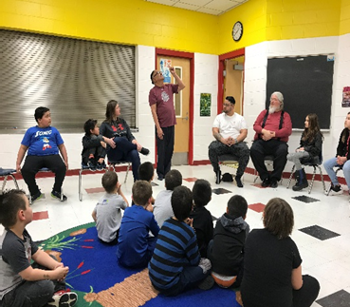
Gordon Jourdain visited to and tell stories.

Instructional Program, Curriculum, and Staffing
Oshki Ogimaag utilizes a multi-tiered system of supports framework to meet the instructional needs of all students. Effective universal instruction and interventions are provided for all students, including students with disabilities, who need various levels of supports to meet grade level standards.
Curriculum design is accomplished through a team process. Educational products are developed over one or two quarters, depending upon theme. These themes provide an integrating context for students to accomplish learning targets and develop academic skills within a culturally responsive framework.
Examples of current and past themes include: Wild ricing (start to finish), Community Alphabet Book, Sugarbush, Tree Unit, Moose, Ojibwe Full Moon paintings, a Winter Count (Yearlong Weekly Observations of the Environment), Constellation Stories, rewrite a legend making it a creative writing assignment, Cattails, and Leaves.
Direct instruction in standards based math and reading skills is provided. Through integrated student projects, skills are applied and explored by using a real world application. To provide direct instruction in academic content areas, OOCS utilizes curriculum programs balanced with locally developed instructional materials. OOCS utilizes the Daily 5 framework, which builds behaviors of independence and stamina in all academic areas by structuring literacy time such that students develop lifelong habits of reading, writing, and working independently. The CAFÉ system is used to assess, instruct, and monitor student progress in the areas of comprehension, accuracy, fluency, and expanded vocabulary. In the area of writing, the OOCS Mentor Text Library includes resources to help teach writing, as well as the tools necessary to implement skill based instruction by using mentor texts. To provide writing instruction teachers utilize the workshop framework for instruction and practice in the classroom. This framework breaks down writing time into four areas: a lesson, writing time, student/teacher conferencing, and sharing. Within that framework, “The 6+1 Traits of Writing” approach used. This approach provides a language for applying seven specific attributes of good writing to their work: ideas, organization, voice, word choice, sentence fluency, conventions, and presentation. This approach also emphasizes assessment methods to inform instruction and provides resources on how to address specific traits in the instruction time.
Mathematics instruction is provided by using the Everyday Mathematics Curriculum teachers are now following a Daily 3 framework for Math. The following curriculum programs complement field experiences, local experts, and cultural knowledge in order to ensure all standards are met: FOSS Science (Science), Timelinks (McGraw-Hill, Social Studies). FOSS Science teaches through experimentation and observation and provides many opportunities for reading integration. Timelinks provides core content, leveled books, activities, and technology integration. Teachers use Private Eye Observation, Beetles and Writing in Science to help integrate subjects.
OOCS also provides instruction in the area of Anishinaabe language and infuses cultural topics and priorities within the state academic standards. An emphasis of academic programming is to provide an accurate portrayal of who the Grand Portage Anishinaabeg are, and where we came from. This is largely connected with our environmental education programming, use of community presenters, field trips to important places, and an accurate representation of history

Remediation and acceleration are determined through a data based, problem solving MTSS school wide process. A data team meets monthly to evaluate student data and determine necessary programs and how it will be staffed. Remediation is provided by identifying a specific skill for intervention, while also ensuring children receive grade level, standards based curriculum. A licensed teacher provide math and reading intervention programs, and student support staff person helps design behavioral interventions. With a very small student population, OOCS teaching strives to understand each student’s individual needs. Small class sizes and multi-age groupings provide the opportunity for differentiation within the classroom.

School Wide Assessment | Calendar | Information Received
NWEA – Map: All Grades | Fall, Spring | Math and Reading RIT score, goal areas of strength and weakness, specific skills mastered and in development. Lexile Score
FASTbridge Assessment | Fall, Winter, Spring | Math, Reading and Behavior scores. Goal areas of strength and weakness, specific skills mastered and in development.
Fountas and Pinnell Reading Assessment | Fall, Winter, Spring | Instructional level, reading level, comprehension rate, accuracy, and occurrences of self-correction.
MCA Testing | Spring | Grades 3-6, Math and Reading; Grade 5 Science; Proficiency and Growth
In addition to formal school assessments, teachers provide and document continual informal assessments during the school day. To implement accelerated and remedial programming, staff utilize curriculum based interventions and utilize standards based technology program Learning A-Z online guided reading program which provides skills reports based on comprehension quizzes of many leveled e-books.

OOCS did not have a special education teacher on staff during the 2019-2020 SY. OOCS contracted with Indigo Education for SPED Director services; Tiny Eye for service providers in the areas of speech/language and occupational therapy; and an independent school psychologist. The special education director is on site once a month and is available by phone and emails at other times. The speech and OT therapist meet with students via skype and are also available through skype for parent meetings.
OOCS staff meets monthly as needed for child find and data meetings. Those in attendance are the director, and licensed teachers. Interventions are established for students in six week cycles and documented. If students receiving intervention continue to stagnate or regress, then an evaluation for special education services is recommended. OOCS strives to eliminate all potential barriers to a child’s learning prior to special education.
OOCS has an inclusive special education model following the least restrictive environment. All services are provided on site, we work with many third party agencies and service providers to meet students’ needs. All students receive individualized instruction in standards based goal areas determined by the IEP team. The special education teacher also provides services to students in the classroom in areas of reading and math. Paraprofessionals support the work in the classroom.

In 2019 Erik Martin Redix, Ph.d. (Misko-anang) joined our staff as the Anishinaabe Language Director. He brings with him skill and knowledge of the Anishinaabe Language and also the culture.
The language is taught daily to all students by grade level. As students are ready to learn to read and write some of the language, Misko-anang patiently walks the students through that process. The students are learning to ask questions to their peers and answer their peers using the Anishinaabe language, teaching them to listen and speak so they can have a conversation, not just say commands. Currently the rest of our staff have varying levels of speaking the Ojibwe language, all are encouraged to learn the language as they can. We are infusing the language into the culture so that it becomes natural to use.
Misko-anang started a language table in the fall of 2019 inviting any community members to participate in weekly evening sessions. There was a minimum of 10 adults that attended each week through the winter until covid-19 forced us to shut down- as of October 2020 we have not made a plan for starting up our evening language program again, we may have to put this on hold until 2021.

Paraprofessionals and support staff have instructional experience, community/cultural knowledge, and are essential in the area of building family and community partnerships and promoting student motivation. Having a high number of Anishinaabe staff members within the building is important due to our high percentage of Anishinaabe children. This provides positive, professional role models for children as they develop.

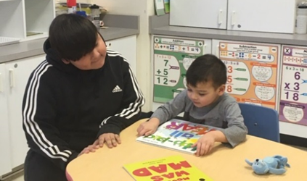
Oshki Ogimaag does not have an English Learner program due to having no ELL students.

Reading Buddies.

School Calendar
In 2019-2020 OOCS students had 161 days of school. Our school day is from 8:00 am – 3:15 pm each day. Students have 30 minute for breakfast and lunch, and 30 minutes of recess per day. This leaves 345 instructional minutes per day totaling 55,545 minutes per year. Staff and vacation days are coordinated with county school days to the extent possible in order to ensure consistency for families with children in multiple schools and to celebrate common community holidays in line with Grand Portage Reservation’s staff holidays.

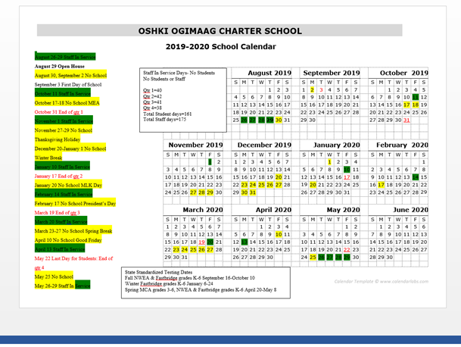

6. Innovative Practices & Implementation

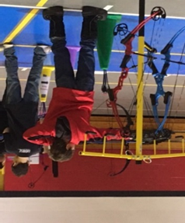
Staff strategically design and select activities and strategies that align with the school’s mission. One way in which we work to accomplish this is by developing and maintaining strong community partnerships. These partnership not only benefit our facility, infrastructure, and operations, but also academic programming.
By working with community knowledge holders we provide a balanced perspective to all content areas. Cultural knowledge is engrained with other subjects. One example illustrating this implementation is a partnership between a federal agency, state agency, and community agency to harvest and process Wild Rice. With the help of school staff, staff from GP Trust lands, GP National Monument and community members and parents, all students in grades 2-6 were able to go in canoes and knock the rice, help clean it, parch the rice, dance on the rice and winnow it. Students in grades K-1 were able to help in the last few steps of ricing. In 2019-20 students in Kindergarten through 6th grade at weekly archery instruction taught by staff members from the GP State Park. The Park Rangers were trained instructors with all of the equipment needed to teach all students in each grade. Students in grades 4-6 were able to compete in a completion held in Virginia- they would have had more opportunities to compete had Covid-19 not interfered.

Archery practice.

Swimming lessons.
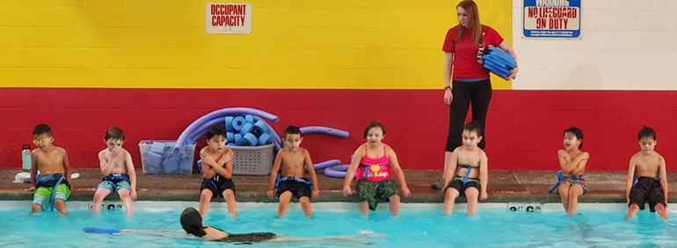
Other programming that took place during the school year was DARE, which was sponsored and presented by the Cook County Sheriff’s Department; swimming lessons taught by staff from the YMCA was grant funded; weekly tennis offered Cook County Tennis Association- this was also grant funded and our school was able to obtain a lot of equipment to use for future years. A tennis instructor came weekly and taught phy ed class that taught a lot of beginner tennis playing skills. Classroom staff were also involved in these classes so they are now able to continue with many of the skills.

Anishinaabe language is engrained within the school day. For example, the school building itself is labeled. Students greet one another in morning meeting in Anishinaabemowin. As well as saying good-bye at the end of the day in Anishinaabemowin. While students are learning things like: day, month, and year they are learning those concepts in both English and Ojibwe which requires high level thinking skills. Students are learning to identify local wildlife, trees, plants, and landmarks in subject areas. Students at OOCS are learning to also identify these things in the Anishinaabe language. When students collected their sap from taps they put in at a local Sugar Bush, they heard Grand Portage traditional stories from an elder about the Sugar Bush. You will read about other ways that we incorporate the culture in our school activities throughout the report.

Students at OOCS have opportunity to learn about current research being conducted by the Grand Portage Band of Lake Superior Chippewa and the 1854 Treaty Authority. Grand Portage’s Trust Lands Department is consistently viewed as a model in research design and implementation. Research on topics such as moose and wolf populations, climate change, and other large scale issues are being done on Grand Portage. OOCS students have access to this research for all projects and activities. Students also have access to the professional staff conducting this research. Through research being modeled to the students, and actively engaging them in the process Trust Lands Staff help support the development of student’s research skills, data collection, and analytical skills.

School staff have been trained in implementing a school garden program. This program includes maintaining a school garden off site, garden plots on site, and a greenhouse. Students have been actively involved in planning, planting and harvesting the garden. They are also learning a lot of science while doing so. Likewise, students maintain journals and measure plant growth. More importantly, OOCS students know where food comes from and will have the lifelong skills of knowing how to grow healthy food for their family. OOCS is proud to be an integral part of the community wide gardening program. Students get extra practice doing this when preparing for our Annual Feast which is held on Indigenous Day each year. They enjoy making breads and soups and then eating with their families.

OOCS believes in building relationships as a strategy to support student engagement and school success. Relationships between children and elders are important. OOCS works with the Grand Portage Elderly Nutrition Program to conduct a “Reading with Elders” Program. Groups of students read with elders two times per month at the attached Community Center. The purpose of this program is to provide students with reading practice as well as develop intergenerational relationships. 8-10 community members volunteer each session, and this program has been very successful.
The OOCS teaching staff continue to do a remarkable work in the area of language arts instruction, teachers and instructional leader attended the Daily Café week long training, continue to implement ideas and suggestions from the Daily Five and since being at the training have a more through grasp of implementing it. Teachers have also been trained in The Orton-Gillingham training and are implementing many of those strategies in their reading program in the 2019-20 school year.

All staff members participated in the Responsive Classroom training before the 2017-2018 school year. When used consistently throughout the school it is very effective and students are able to understand and remember expectations. Teachers also have a better understanding about morning meeting and some games to play. We continue to use the Responsive Classroom methodology throughout the school day.
With a small team, turnover is a challenge. Considering a limited hiring pool, we are fortunate to have a hard working, talented, and committed staff. Staffing continues to be a difficult task. An emphasis on retaining teaching staff and providing development opportunities is essential. In addition, ensuring that all work is documented and integrated into the school culture is important in ensuring that with each person who comes in, the students gain from that individual’s work and knowledge. With each individual that enters our doors we are granted an additional area of expertise.
The Special Education Team has been working hard to ensure that our practices are procedural, legal, and effective. The Special Education Program at OOCS has made significant gains, and we have an increasing number of students meeting annual goals and making significant growth academically. OOCS had zero findings of non-compliance resulting from a targeted fiscal review conducted by the State of Minnesota Special Education. Although we did not have a full time licensed special education teacher on staff we used the resources we had to make sure students were still able to receive one-to –one instruction, specialized instruction and still help them in the learning areas they needed assistance in. Our Instructional Leader spent extra time working with students and staff to help lead in the right direction to help all of us go further in this area. OOCS staff and the Special Education Director worked closely with the Department of Education to keep them well aware of our situation. We also communicated with parents and guardians of special education students so they were also aware that we were doing the best we could with the resources we had.
Stamina, independence, and vocabulary have been identified as three areas where students struggle in taking state accountability tests. In addition to formative instructional programs, increasing math and reading instructional time, and providing students with increased practice and exposure to this type of evaluation, staff will use the Daily 5 to increase these skills. In order to providing a framework for instruction, this framework has the potential to support increased testing skills.

7. Academic Performance: Goals & Benchmarks

Progress on Osprey Wilds Contractual Academic Goals & WBWF Alignment

World’s Best Workforce (WBWF) Goal Areas:
- Ready for Kindergarten [R4K]: All students are ready for kindergarten.
- Reading Well by 3rd Grade [RG3]: All students in third grade achieve grade-level literacy.
- Achievement Gap Closure [AGC]: All racial and economic achievement gaps between students are closed.
- Career and College Ready [CCR]: All students are career- and college-ready before graduating from high school.
- Graduate from High School [GRAD]: All students graduate from high school.

Indicator 1: Mission Related Outcomes

Goal: Over the period of the contract, students at Oshki Ogimaag Charter School (OOCS) will demonstrate Anishinaabe language and culture skills.

Measure 1.1 – From FY18 to FY20, the aggregate percentage of students who attend OOCS will demonstrate growth on their Anishinaabe language oral communication skills - from basic developmental proficiency stage to intermediate developmental proficiency in the areas of listening and speaking from fall to spring- as measured by the Ontario Ministry of Education’s First Nations Language Benchmarks will be at least 75%.

Oshki Ogimaag Charter School | Number of students who demonstrated growth on their Anishinaabe language oral communication skills - from basic developmental proficiency stage to intermediate developmental proficiency in the areas of listening and speaking from fall to spring- as measured by the Ontario Ministry of Education’s First Nations Language Benchmarks | Total Number of Students  (Grades K-6) | Percentage of students who demonstrated growth on their Anishinaabe language oral communication skills - from basic developmental proficiency stage to intermediate developmental proficiency in the areas of listening and speaking from fall to spring- as measured by the Ontario Ministry of Education’s First Nations Language Benchmarks
FY18 | 20 | 20 | 100%
FY19 | 17 | 17 | 100%
FY20 | 21 | 21 | 100%
Students are not only showing growth in basic to intermediate speaking skills. But all students are naturally learning the listening skills so that they can have a conversation with others. (A very important part of learning any language).
Students that are in grades 4-6 are also showing some beginning writing, and reading skills.

Measure 1.2 – Each year FY19 to FY20, all students will participate in cultural activities, learn cultural practices and listen to traditional stories to gain cultural awareness, skills and understandings. Students will demonstrate learning of cultural traditions through demonstration, reflections, art, oral presentations and writing assignments that document their learning in these areas. Student learning will be evaluated based on a rubric to be developed no later than fall 2018. In aggregate from FY19-FY20, the aggregate percentage of students in grades K-6, who score 75% or higher on the rubric which is completed throughout the year and each spring will be at least 75%.

 | Number of students K-6 students that were accessed Spring 2019 | Number of students K-6 that meets target in Cultural Knowledge | Number of students K-6 that exceeds target in Cultural Knowledge | Percentage of Students that were able to demonstrate Knowledge and Cultural Awareness
FY19 | 17 | 5 | 12 | 100%
FY20 | (see below)

Due to covid-19 we were unable to assess this area in the Spring using a formal rubric and formal opportunity- however in looking at many informal assessments and evaluating the many activities and opportunities students had to participate and learn about their Ojibwe culture- I am confident in believing students would have exceeded in sharing their knowledge of the Ojibwe culture to anyone that asks. Below is a small sampling of some of the opportunities are students participated in culturally.
Students in K-2nd grade created monthly Full Moon Art. This artwork contained language, cultural knowledge and seasonal events. During August Manoominike Giizis- Wild Ricing Moon depicted the fall Ojibwe constellation of Mooz, our February moon Namebini Giizis contained Spring and Winter Ojibwe constellations of Wintermaker and Curly Tail as well as the Sucker Fish who gave his life for Ojibwe to survive a harsh winter. The Full Moon lessons are embedded with Ojibwe star knowledge, Ojibwe names for moons and are full of our Culture!
Students in 4-6th grade gave input to our plan for our Wild Rice Harvest. Students 1-6th grade knocking rice and our youngest Kindergarten learning from shore in a canoe. All students participated in our Wild Rice Processing at the Grand Portage National Monument Ojibwe Village.
In the fall our students in 4th -6th grades dug a cache pit to bury a feast of wild rice, dried fruit and veggies, maple syrup, and asemaa in preparation for our Sugarbush camp.
Rabbit snaring: In February, 4th-6th graders snared rabbits. Each student was responsible for one snare. For two weeks, students went and checked snares daily. These activities were supplemented with traditional Ojibwe teachings in the classroom about rabbit snaring and resource management. Three rabbits were caught and used to supply food for a community presentation on rabbit snaring and preparing rabbits.
Sugarbush: We started a Sugarbush Committee and began making plans for Sugarbush. In mid-March, a demonstration showed students how to tap trees at the beginning of the season, and two trees were tapped. However, the closing of schools statewide meant that students could not continue tapping more trees and producing syrup once the season began. Through distance learning, we demonstrated the process of processing syrup at a staff members’ sugarbush.
All our students helped our school garden by starting seeds, discussions about garden plans (themes), and lessons; with the Distance Learning we have continued lessons but for starting seeds and gardening at home.
During Winter 2019-2020 100% of the students in grades 4-6 used phenology data to do a Winter Count Project. Students learned about Lakota Winter Counts and the history of the Lakota Tribe told through the annual winter count. Students made observations and gathered phenology data, illustrated on a paper hide and made a corresponding key. We then took the illustrations and data students observed and etched their illustration of the phenology data onto a leather hide. The leather hide will be displayed at our school showing our students the importance of their work and we are hoping to continue to record the data in a similar way.

Indicator 3: Reading Growth

Goal: Over the period of the contract, students at OOCS will demonstrate growth in reading as measured by state accountability tests and nationally normed assessments.
Measure 3.1 [CCR] –From FY18 to FY20, the average growth z-score for students grades 4-6 on state accountability tests will be equal to or greater than 0.00.
Measure 3.2 [CCR] – From FY18 to FY20, the aggregate percentage of students’ grades 4-6 who achieve a positive z-score on state accountability tests will be greater than 50.0%
Measure 3.3 [CCR] – From FY18 to FY21, the aggregate percentage of students in grades K-6 who meet their fall to spring (FY21 fall to winter) NWEA RIT expected growth target will be at least 50%.

Measure 3.3 Performance Data:
Reading: NWEA, grades K-6
Oshki Ogimaag Charter School | Number of Students K-6 meeting fall to spring (except FY21 fall to winter) NWEA RIT expected growth target | Total Number of Students K-6 | Percentage of Students meeting expected growth target
FY18 | 7 | 18 | 39%
FY19 | 6 | 17 | 35%
FY20 | (see paragraph below)

Reporting on measure 3.3- FY20 OOCS used the assessment program FASTbridge. The testing cycle is similar to NWEA- the scoring looks different and we are still working out the comparisons.
FAST does not show expected growth in the same way, making it more difficult for the writer to it in this area. We can report the growth that we did have from Fall to Winter for FY 20.
We assessed 21 students in the Fall and Winter. 19 of those students maintained or increased their score. 8 students increased by 0-5 points; 5 students increased by 6-10 points; 1 student by 11-15 points; 3 students by 20-30 points; 2 students by 30-41 points.

An aReading Benchmark for Academic Year 2020-21 is included at the end.
*Please note that the benchmark scores to change slightly year to year, we do not have a 2019-20 table to include so please keep that in mind when referring to it as a guidance.
It is also noted by the school that remaining at the same score from one testing cycle to the next is not necessarily maintaining- that was simply how the students score turned out.

Indicator 4: Math Growth

Goal: Over the period of the contract, students at CCS will demonstrate growth in math as measured by state accountability tests and nationally normed assessments.
Measure 4.1 [CCR] –From FY18 to FY20, the average growth z-score for students grades 4-6 on state accountability tests will be equal to or greater than 0.00.
Measure 4.2 [CCR] – From FY18 to FY20, the aggregate percentage of students’ grades 4-6 who achieve a positive z-score on state accountability tests will be greater than 50.0%
Measure 4.3 [CCR] –From FY18 to FY21, the aggregate percentage of students in grades K-6 who meet their fall to spring (FY21 fall to winter) NWEA RIT expected growth target will be at least
50%.

Measure 4.3 Performance Data:
Math: NWEA, grades K-6

Oshki Ogimaag Charter School | Number of Students K-6 meeting fall to spring (except FY21 fall to winter) NWEA RIT expected growth target | Total Number of Students K-6 | Percentage of Students meeting expected growth target
FY18 | 11 | 18 | 61%
FY19 | 6 | 17 | 35%
FY20 | (see paragraph below)

Reporting on measure 4.3- Reporting on measure 3.3- FY20 OOCS used the assessment program FASTbridge. The testing cycle is similar to NWEA- the scoring looks different and we are still working out the comparisons. FAST does not show expected growth in the same way, making it more difficult for the writer to it in this area. We can report the growth that we did have from Fall to Winter for FY 20.
OOCS staff assessed 21 students in the Fall and Winter. 3 of our students did not maintain or gain the expected growth in math. 4 students maintained their score from fall to winter; 10 gained 1-5 points; 2 gained 6-10 points and 2 gained 11-18 points.

An aMath Benchmark for Academic year 2020-21 is included in the end.

Indicator 5: Reading Proficiency

Goal: Over the period of the contract, students at OOCS will demonstrate proficiency in reading as measured by state accountability tests.
Measure 5.1 [RG3] – From FY18 to FY20, the school’s aggregate proficiency index score for students in grade 3-6 will increase by at least 10.0 points from the baseline proficiency index score (FY14-17 baseline – 14.3) OR will be greater than that of the state for the same grades (3-6).
Measure 5.2 [CCR] –From FY18 to FY20, the aggregate percentage of students in grades K-6 that will achieve grade level proficiency (Average or above) as measured by the spring NWEA assessment as reported on the NWEA “Class Report” will be at least 50%.
Measure 5.3 [CCR] –From FY19 to FY20, the aggregate percentage of students in grades K-6 who meet or exceed grade level reading expectations based on Fountas & Pinnell Instructional Level Expectations for Reading in spring will be at least 50%.

Measures 5.1 Performance Data:

Reading: All State Accountability Tests – All Students (Enrolled October 1, Grade 3-6)

Oshki Ogimaag Charter School | Exceeds | Meets | Partially Meets | Does Not Meet | Proficiency Index
FY18 | 0 | 4 | 0 | 9 | 31%
FY19 | 0 | 4 | 0 | 7 | 36%
FY20 | (See Below)
Due to covid-19 we were unable to conduct the MCA’s.

Measures 5.2 Performance Data:

Reading: NWEA Class Report – All Students (Enrolled October 1, Grade 3-6)

Oshki Ogimaag Charter School | Number of students achieving average or above | Total number of students | Percentage of students achieving average or above
FY18 | 6 | 13 | 46%
FY 18 Grade K-6 | 8 | 18 | 44%
FY19 | 3 | 8 | 38%
FY19 Grade K-6 | 7 | 14 | 50%
FY20 | See paragraph below
FY20 Grade K-6 | 7 | 21 | 33%
Due to covid-19 we did not conduct our Spring assessment. I can report on our reading performance from Winter Scores. Please see table above. I would also like to note that four students receive special education services for reading and so it is obvious that they are not going to score at grade level.

Measures 5.3 Performance Data:

Oshki Ogimaag Charter School | Number meets or exceeds grade level reading | Number does not meet grade level reading | Total Number of Students Accessed | Percentage of students achieving
FY19 | 14 | 3 | 17 | 82%
FY20 | (See Below)
Due to covid-19 and going to Distance Learning we were unable to conduct the F&P in the Spring of 2020.

Indicator 6: Math Proficiency

Goal: Over the period of the contract, students at OOCS will demonstrate proficiency in math as measured by state accountability tests.

Measure 6.1 [RG3] – From FY18 to FY20, the school’s aggregate proficiency index score for students in grade 3-6 will increase by at least 10.0 points from the baseline proficiency index score (FY14-17 baseline – 13.5) OR will be greater than that of the state for the same grades (3-6).
Measure 6.2 [CCR] – From FY18 to FY20, the aggregate percentage of students in grades K-6 that will achieve grade level proficiency (Average or above) as measured by the spring NWEA assessment as reported on the NWEA “Class Report” will be at least 50%.

Measures 6.1 Performance Data:

Math: All State Accountability Tests – All Students (Enrolled October 1, Grade 3-6)
Oshki Ogimaag Charter School | Exceeds | Meets | Partially Meets | Does Not Meet | Proficiency Index
FY18 | 1 | 1 | 4 | 7 | 31%
FY19 | 0 | 2 | 1 | 8 | 23%
FY20 | (See below)
Due to covid-19 we were unable to conduct the MCA’s.

Measures 6.2 Performance Data:

Math: NWEA Class Report – All Students (Enrolled October 1, Grade 3-6)
Oshki Ogimaag Charter School | Number of students achieving average or above | Total number of students | Percentage of students achieving average or above
FY18 | 4 | 13 | 31%
FY18 Grade K-6 | 6 | 18 | 33%
FY19 | 1 | 8 | 13%
FY19 Grade K-6 | 6 | 14 | 43%
FY20 | See paragraph below
FY20 Grade K-6 | 10 | 21 | 48%

Due to covid-19 we did not conduct our Spring assessment. I can report on our reading performance from Winter Scores. Please see table above. I would also like to note that five students receive special education services for reading and so it is obvious that they are not going to score at grade level.

Indicator 7: Science Proficiency (and Growth)

Goal: Over the period of the contract, students at OOCS will demonstrate proficiency and growth in science as measured by student nature journals and scientific notebooks.

Measure 7.1 [CCR] –From FY19 to FY20, 80% of the students in grades K-6 will improve in their ability to record observations using “I notice,” “It reminds me of,” and “I wonder” statements (or other appropriate methods for students K-1). They will use this format in their journaling at least
10 times during each year and demonstrate improvement in terms of the number of observations and the level of detail of the observations from fall to spring as measured by teacher records.

Performance Data: Students sit in the same spot each week to journal about what they see, hear, touch or smell. Journaling time is about 5-10 minutes. Due to Covid-19 and distance learning we were able to have about 20 opportunities of journaling at Wabaan. 21 students that were enrolled at OOCS the entire school year, 15 of those students or 71% had 15 or more journal entries. 86% of the students had 10 or more journal entries. Journaling was encouraged during distance learning, however, records were not kept of how many students did journaling and for how long of time. It was encouraged in part to help students state of mental health.

Indicator 8: Proficiency or Growth in Other Curricular Areas or Educational Programs

Kindergarten Readiness Goal: Increase the number of children who are screened between their third birthday and the start of kindergarten
Measure 8.1 [R4K] –From FY18 to FY20, the aggregate percentage of Kindergarten students entering the school who have completed an Early Childhood Screening will be 100%

Measure 8.1 Performance Data:

Early Childhood Screening

Oshki Ogimaag Charter School | Number of Kindergarten students entering the school who have completed Early Childhood Screening | Number of Kindergarten students entering the school who have not completed Early Childhood Screening before entering school | Total Number of Kindergarten students entering the school | Percentage of Kindergarten students entering the school who completed Early Childhood Screening
FY18 | 4 | 0 | 4 | 100%
FY19 | 9 | 0 | 9 | 100%
FY20 | 7 | 0 | 7 | 100%

Due to covid-19 there was not an Early childhood screening at our school, all students were able to go through an early childhood screening through the Head Start program.

Writing Growth School Goal: Over the period of the contract, students at OOCS will demonstrate growth in writing as measured by a locally-developed assessment rubric.
Measure 8.2 [CCR] –From FY 19 to FY 20, the aggregate percentage of students in grades K-6 who will increase proficiency in writing skills (or maintain if at proficiency) from fall to spring as measured by the locally-developed assessment rubric will be at least 75%.

Due to some staffing issues in FY20, we were unable to focus on schoolwide writing as a large group. Classroom teachers incorporated writing in their classroom as per the state standards for the grades they taught.

Indicator 10: Attendance

Goal: Over the period of the contract, students at OOCS will attend the school at high rates.
Measure 10.1 –From FY18 to FY20, the average of the school’s annual attendance rates will be at least 92.5%
Measure 10.2 –From FY18 to FY20, 80% of students will have an attendance rate of 90% or better on average annually
Oshki Ogimaag Charter School | Attendance Rate
FY18 | 87%
FY19 | 88%
FY20 | 91%

Oshki Ogimaag Charter School | Percentage of students with an attendance rate of 90% or better
FY18 | 50%
FY19 | 59%
FY20 | 64%

Federal and State Accountability

It is difficult to find and attain experienced teachers in our area. Our school is located in remote Northeastern Minnesota on an Indian Reservation, housing is limited in our immediate area and can be expensive away from the reservation. Most people would rather live and work in larger towns and cities. People are sometimes willing to move and work here for a year or two but then want to move on to larger schools and areas. We have been fortunate to find qualified paraprofessionals from our community, currently all of our paraprofessionals have prior experience working with students and have lived in Grand Portage most of their lives so they know the students and families well as well as the history of the school and the community.

The low number of students at our school it is difficult to measure any achievement gap data. We have a high number of students that receive free/ reduced price lunches, a high number of American Indians and a high number of special education students. We treat them all the same, teach to their level of learning, use a variety of teaching styles and keep encouraging them to do their best. By incorporating their culture in our daily teaching we hope they will leave the anger and frustration behind and come to school and feel safe and ready to learn.

8. Educational Effectiveness: Assessment & Evaluation
OOCS hired an Instructional Leader (IL) to help mentor teachers and to help fill in some gaps in our curriculum planning, evaluation of staff, knowing how to use assessment scores and learning when and how to provide rigor to our curriculum. The IL and Director met many times throughout the year, including often through the summer, to make plans for improvement in our curriculum, teaching styles and how to meet the needs of students. The IL has showed us how to improve instruction, improve curriculum and, in turn improve student achievement. She is helping create an atmosphere that has rigor and is fun for students, she is helping with classroom management challenges and working with staff to improve their teaching practice through coaching, professional development, modeling and collaborative planning. We are working together to find effective ways to evaluate the data from testing and to use it to strengthen our instruction and curriculum.

The Board of Directors and School Director are all working more effectively to follow the plans of evaluating all staff members. It is taking some time to iron out the wrinkles but progress is being made for the evaluations to be more effective to help develop professional improvement plans and develop staff in service days.

In 2019-2020 we had 5 licensed teachers plus our IL whom is also a licensed teacher and spent some time working 1:1 with students and teachers. - Three have over 10 years of experience each, one of those has his doctorate and taught at college level. One was in her 4rd year of teaching and one had tier 1 licensure. As mentioned earlier we struggle with obtaining licensed teachers due to our remote area. We continue to advertise and reach out to colleges through edPost, GoldPass, MACS, BOREAL.

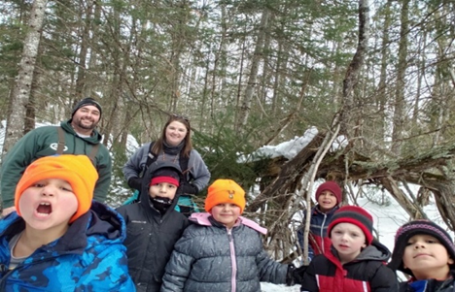
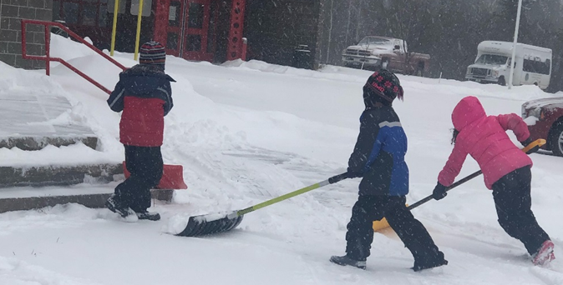
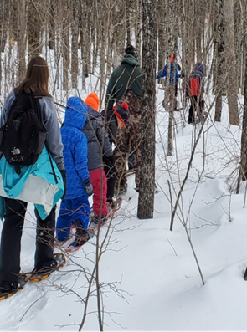

Outdoor learning and helping.

9. Student & Parent Satisfaction

Five families filled out and returned the family survey for the 2019-20 SY- we sent the survey out in late winter and sent many reminders and still received only five back. Those five were very positive regarding how the parents felt about the safety of their student and the education their student receives at OOCS. The above is a portion of the questions asked on the survey.
Along with the family survey, each year the Parent Advisory Committee is asked to issue a vote of concurrence or Non-concurrence (whichever they feel may be accurate). This vote of concurrence attests that they feel the school board and school are compliant with MN statutes and that the needs of American Indian students are being meet. For the past several years the Parent Advisory committee has signed off on this resolution in annual compliance.
Students were not formally surveyed in 2019-20 due to covid-19 and distance learning starting in March.
Practicing for wild ricing in the canoe.
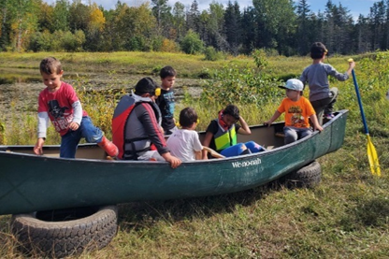

10. Environmental Education

The mission of Oshki Ogimaag’s authorizer, the Osprey Wilds Environmental Learning Center, is to instill a connection and commitment to the environment in people of all communities through experiential learning. Osprey Wilds defines environmental education as the implementation of values and strategies that foster learning and create environmentally literate citizens who engage in creating healthy outcomes for individuals, communities, and the Earth. The overarching goal of environmental education is an environmentally literate citizenry. The test of environmental literacy is the capacity of an individual to work individually and collectively toward sustaining a healthy natural environment. This requires sufficient awareness, knowledge, skills, and attitudes in order to create a healthy planet where all people live in balance with the Earth.

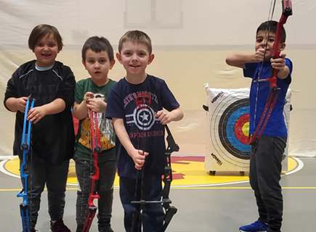
At OOCS, students are provided with meaningful opportunities to explore their local ecosystem through integrated, standards based projects and field experiences. By exploring the community in which we live, students are better able to make connections between what they read and learn within the classroom to the natural environment that surrounds them. As part of our Outdoor Education we have started Wilderness Wednesday at Wabaan. Staff and students spend approximately 3 hours each week exploring, observing, journaling and learning at a place in the Wilderness known as Wabaan (Wabaan is an Anishinabe (Ojibwa) word meaning it is tomorrow. It signifies commitment to a holistic program of teaching and learning that acknowledges the impacts of colonialism, and draws on the wisdom of ancestral teachings and contemporary leaders to put Indigenous futures into Indigenous hands.) Teachers are able to extend a lesson that was taught in the classroom into the outdoors and expand. Students are able to observe the changes of nature through season to season, year to year. We also conduct a sugar bush camp here, we have been able to learn about ecological changes to the environment and how this could affect our future. Our Environmental Learning does not end there-
Another strategy to provide real world, field based environmental education is to connect with local scientists employed by the Grand Portage Band of Lake Superior Chippewa. This partnership provides an in-kind contribution to our organization, and gives students access to Tribal research and the opportunity to participate in current environmental initiatives. Staff members include credentialed biologists, fish and wildlife experts, wetlands specialists, water and air quality specialists, balanced with local Anishinaabe experts with traditional knowledge of our ecosystem. This partnership is essential in our ability to achieve our goals.
We also have a partnership with the Grand Portage Agricultural and Development Committee and Grand Portage Health Service to implement the school garden program and to assist with the community gardening.
Both partnerships provide the opportunity for classroom based education, field work, and utilize language and culture as an integrating context. The school grounds house a greenhouse and teaching gardens, where a tremendous amount of instruction takes place. In addition, the community garden is located 6.5 miles from the school grounds. Students do plant and harvest the garden, the larger garden’s purpose is for production rather than teaching. With the help from the community we are able to help provide produce for school lunch, elderly nutrition program lunches and the summer food program.
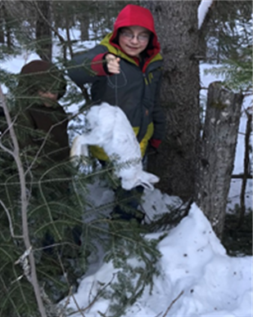
We were able to integrate EE into our distance learning it in many ways- some key projects were planting, learning about bee activities, watching caterpillars turn to butterflies and then releasing them. The most beneficial part was many families were far more involved in EE activities then they otherwise would have been. We now have more families have small little garden plots or patio gardens at their homes due to offering seeds, dirt and the encouragement to plant and watch it grow.
To continue offering such hands on activities to families through distance learning, we will continue seeking grant funding to help fund such projects so we can provide materials to families for them to experience the activities at home. Without said funding our school and families would be unable to provide the hands on EE activities such as gardening, caterpillars to butterflies, kites,
Rabbit snaring.

11. Governance & Management
Includes Annual Board Training & Administrator Professional Development Report(s)

BOARD OF DIRECTORS
Oshki Ogimaag School Board currently consists of seven very dedicated individuals, all have been active members of the board for several months and have a vested interest in our school and the community.

Member Name | Board Position | Affiliation | Date Elected | Date Seated | Term End Date | Email Address
Leslie Olson | Chair | Parent | 12/2017 | 1/2018 | 12/2020 | Leslie.olson@state.mn.us
Yastrianne Spry | Vice Chair | Parent | 12/2019 | 1/2020 | 12/2022 | Yanne.spry@gmail.com
Erik Redix | Secretary | Teacher | 12/2018 | 1/2019 | 12/2021 | redix@oshkiogimaag.org
John Morrin | Member | Community Member | 12/2018 | 1/2019 | 12/2021 | jmorrin@grandportage.com
Patty Winchell-Dahl | Member | Community Member | 12/2018 | 1/2019 | 12/2021 | pwinchelldahl@yahoo.com
Travis Novitsky | Member | Community Member | 12/2019 | 1/2020 | 12/2022 | Travis.novitsky@state.mn.us
Carol Cleveland | Member | Community member | 12/2019 | 1/2020 | 12/2022 | ccleveland@grandportage.com
Carmen Keyport | Ex-Officio | School Leader | *** | *** | *** | director@oshkiogimaag.org

Board Training and Development
The current board of directors have been using the book CHARTER SCHOOL BOARD UNIVERSITY as their training tool. Each month they read and discuss a chapter of the book. As members become more comfortable the discussion has become more engaging. The writer feels this book has taught the group a lot about what the role of the board is and what the role of the administration is in many instances. As new members come on board- part of the onboarding process is to review the chapters that have already been discussed. This is could review for current members and a good introduction to new members.

Initial Training

It has been helpful for our Board of Directors to be able to take the Initial Training Online. MN Charterboard.com has been very helpful to small charter schools in rural areas; it is free training and members can take the training anytime.

Initial Training
Board Member Name | Original Date Seated | Board’s Role & Responsibilities | Employment Policies & Practices | Financial Management
John Morrin | 2010 | 5/22/2010 K. Klandeud MN School Board Assoc 1/20/2018 Eugene Piccolo MAC Piccolo MAC | 5/22/2010 K. Klandeud MN School Board Assoc 1/20/2018 Eugene Piccolo MAC | 5/22/2010 K. Klandeud MN School Board Assoc 1/20/2018 Eugene Piccolo MAC
Leslie Olson | 1/2015 | 4/18/2015 Ellen McVeigh & Linda Tacke Univ St. Thomas | 4/18/2015 Ellen McVeigh & Linda Tacke Univ St. Thomas | 4/18/2015 Ellen McVeigh & Linda Tacke Univ St. Thomas
Erik Redix | 1/2019 | 6/1/2019 Eugene Piccolo MACS | 6/1/2019 Eugene Piccolo MACS | 10/31/2019 Eugene Piccolo MACS Online
Travis Novitsky | 1/2020 | 6/16/2020 MN Charterboard.com | 6/16/2020 MN Charterboard.com | 6/16/2020 MN Charterboard.com
Patty Winchell-Dahl | 1/2019 | 6/1/2019 Eugene Piccolo MACS | 6/1/2019 Eugene Piccolo MACS | 1/2020 Eugene Piccolo MACS Online
Yastrianne Spry | 1/2020 | 7/5/2020 MNCharterboard.com | 7/5/2020 MNCharterboard.com | 10/26/2020 MNCharterboard.com
Carol Cleveland | 1/2020 | 10/5/2020 MN Charterboard.com | 6/25/2020 MN Charterboard.com | 7/28/2020 MN Charterboard.com

Annual Training
The first table shows training that individual members have taken on their own and reported to the writer that they have taken.
The second and third table are trainings that were offered at board meetings.

Annual Training – FY20
Board Member Name | Date of Training | Training Title or Topic | Presenter or Trainer
Leslie Olson | 6/14/2019 | Active Threat Awareness and Security Awareness Training (Cyber Security online Safety) | MN DNR webinar
Leslie Olson | 6/15/2020 | Prohibition of Harassment and Discrimination and Code of Ethics and Conduct | MN DNR webinar
Leslie Olson | 1/22/2020 | Preventing Conflicts of Interest | MN charterboard.com
Leslie Olson | 3/14/2020 | Use of Public Funds; Early learning Program requirements; Adopt Required Reports #3 Annual Report; Evaluate School Leadership | MNcharterboard.com
Carol Cleveland | 6/30/2020 | Evaluate School Leadership | MNcharterboard.com
Patty Winchell-Dahl | 03/27/2020 | Understanding OML & COVID-19 | Board chat/ CharterSource

 |  | Annual Training – FY20
Board Member Name | Charter School Board University, Chapter 7 Governing vs Managing  October 16, 2019 |  | Charter School Board University, Chapter 8 What Governing and parenting Have in Common  November 20, 2019 | Charter School Board University, Chapter 8-9 Two Questions People Always Ask about Boards and Review Chapter 8  March 11, 2020 | Charter School Board University, Chapter 10 Fiduciary Responsibility  April 15, 2020
John Morrin | Yes |  | No | Yes | No
Jared Swader | Yes |  | Yes | N/A | N/A
Leslie Olson | Yes |  | Yes | Yes | Yes
Erik Redix | Yes |  | Yes | Yes | Yes
Patty Winchell-Dahl | Yes |  | Yes | Yes | Yes
Travis Novitsky | N/A |  | N/A | Yes | Yes
Carol Cleveland | N/A |  | N/A | Yes | No
Yastrianne Spry | N/A |  | N/A | Yes | Yes

 | Charter School Board University, Chapter 11  Policy Governance  May 20, 2020 | Charter School Board University, Chapter 12 Pareto: A Deceased Economist That Can Help Your Board
John Morrin | Yes | Yes
Jared Swader | N/A | N/A
Leslie Olson | Yes | Yes
Erik Redix | Yes | Yes
Patty Winchell-Dahl | Yes | Yes
Travis Novitsky | Yes | Yes
Carol Cleveland | No | Yes
Yastrianne Spry | Yes | No

MANAGEMENT
Carmen Keyport has served as the Director since March 2017. Prior to being Director Carmen was the Business Manager and also periodically served as Interim Director at OOCS for 6 years; she was responsible for finances, HR, oversaw transportation and food service area and assisted students and staff when needed. She continues to support the mission of OOCS and work with the community to develop partnerships to help students succeed, she still manages the finances and school compliance as well as serving on the board as an ex -officio member
Before moving to Grand Portage, Carmen had over 17 years of experience working in early childhood and 5 years of experience in a variety of financial positions- this includes being a lead teller at a bank and financial officer for a Supported Living Services for Adults with Disabilities Company.

LIST OF ADMINISTRATORS
Carmen Keyport, Executive Director

PROFESSIONAL DEVELOPMENT PLAN FOR Carmen Keyport, Executive Director

Professional Development Goals/Areas of Focus for 2019-20: The Director intended to continue learning about childhood mental illnesses, will continue to stay updated on the states programs: STARS, MARSS, UFARS, Special Education, Indian Education, etc. An area of focus is to perform more meaningful staff observations and evaluations and help staff set achievable goals for themselves.

Activities Completed/Progress/Results for 2019-20:
There were several webinars and zoom meetings held during 2019-20. They included an Impact Aid webinar, SRSA webinar, School Board training webinars, Net generation (Tennis) webinar, The MACS quarterly meeting (in person), MACS weekly meetings, MDE weekly call ins, Mental Health Training (in person) (focusing on children’s mental health) , Social Thinking Training by Mary G.,

Professional Development Goals/Areas of Focus for 2020-21: Childhood Mental Illness and Depression continues to be an important goal, especially with covid-19 and with our isolating area of where we live; so this will continue to be a goal to work on and focus to learn more about.
Other areas of focus will be Leadership and to continue to stay updated on the states programs: STARS, MARSS, UFARS, Special Education, Indian Education, etc.

12. Staffing

It is important to the school and community to find qualified individuals to work and teach at our school that are interested in providing a high quality education to our students. We look for staff that are interested in teaching using the school with no boundaries and are looking for ways to encourage the highly qualified teachers to stay longer than a couple of years.

2019-20 Staffing

2019-20 Licensed Teaching Staff
Name | File # | License and  Assignment (subject/grades) | 2020-21 Status* | Comments  Include information regarding special licensure (e.g., Community Expert) or other relevant information.
Jeana Van Dyne | 493449 | K Teacher | R
Bridget LeGarde | 342031 | Grades 1 and 2 Teacher | NR
Brooks Midbrod | 498782 | Grades 4-6 Teacher | NR | Tier 1 licensure, did not renew
Erik Martin Redix, Ph.d (Misko-anang) | 1002943 | Anishinaabe Language Director | R | Tier 3 licensure
Jaye Clearwater-Day | 285814 | Long Term Sub for grades 1 and 2 | R
* R = Returning, NR = Not Returning

2019-20 Teacher Professional Development Activities:
The following are some titles of webinars that were attended by teaching staff at OOCS:

A positive situation from covid-19 and distance learning; MDE offered many online trainings for teaching staff members. Some that were attended by OOCS staff along with other trainings through the year were: Supporting American Indian Students and Communities During Distance Learning; Suicide Prevention: Question, Persuade, Refer; English Language Learning in the Classroom; Kindergarten: The First week of School; Cultural Competency Training; Understanding Self-Regulation: Help Your Students Learn to Help Themselves; Mandated Reporting;

Teacher Retention:
We continue to struggle to find highly qualified teachers that want to live in our area. We are in a remote area and it is difficult to retain teachers for more than a few years. In 2019-20 one teacher was able to obtain a tier 1 license- we felt it was not in our best interest to encourage him to pursue his education degree and become licensed to teach our students. In 2019-20 we had another teacher leave for several weeks on medical leave and then in the end she was unable to return- we had a long term substitute teacher who turned in to a full time teacher and has continued on in the 2020-21. We are fortunate in being able to retain our paraprofessionals- the three we currently have our community members, two are AI and all are very dedicated to our school and students.
For 2020 we are fully staffed with three licensed classroom teachers, a licensed special education teacher and a licensed Ojibwe language teacher.
Percentage of Licensed Teachers from 2019-20 not returning in 2020-21 (non-returning teachers/total teachers from 2019-20 X 100) | 40%

2019-20 Other Licensed (non-teaching) Staff
Name | License and Assignment | 2020-21 Status* | Comments
Mary Glasnapp | 386666 Instructional Leader | R | Independent Contract
Noreen Foster | 380968 Director Of Special Education | R | Employed by Indigo Ed
Jan Lippitt | 413046 School Psychologist | R | Independent Contract40%
Danielle Young | Occupational Therapist | R | Employed by Tiny Eye Therapy Services
Rebecca Freeh Thornburg | Speech/Language Pathologist | NR | Employed by Tiny Eye Therapy Services
Gina M. Mcurry Gilreath | Speech/Language Pathologist | R | Employed by Tiny Eye Therapy Services
* R = Returning, NR = Not Returning

2019-20 Non-Licensed Staff
Name | Assignment | 2020-21 Status* | Comments
Bonita Poitra | Home/School liaison | R
Desiree Likiaksa | Sped para | NR
Mary Sherer | Sped para | R
Katherine Sherer | Sped para | R
Monica Morris | Sped para | R
* R = Returning, NR = Not Returning

CURRENT YEAR -

2020-21 Licensed Teaching Staff
Name | File # | License and  Assignment (subject/grades) | Comments  Include information regarding special licensure (e.g., Community Expert) or other relevant information.
Jeana Van Dyne | 493449 | K-Grade 1 Teacher
Jaye Clearwater- Day | 285814 | Grades 2-3 Teacher
Nancy Dumas | 474091 | Grades 4-6 Teacher
Erin Lange | 416804 | Special Education Teacher
Erik Martin Redix, Ph.d (Misko-anang) | 1002943 | Anishinaabe Language Director | Tier 3 licensure

2020-21 Other Licensed (non-teaching) Staff
Name | License and Assignment | Comments
Mary Glasnapp | 386666 Instructional Leader | Independent contract
Noreen Foster | 380968 Director Of Special Education | Employed by Indigo Ed
Jan Lippitt | 413046 School Psychologist | Independent contract
Danielle Young | Occupational Therapist | Employed by Tiny Eye Therapy Services
Gina M. Mcurry Gilreath | Speech/Language Pathologist | Employed by Tiny Eye therapy Services
Rebecca Freeh Thornburg | Speech/Language Pathologist | Employed by Tiny Eye Therapy Services

2020-21 Non-Licensed Staff
Name | Assignment
Bonita Poitra | Home School Liaison
Mary Sherer | Paraprofessional
Katherine Sherer | Paraprofessional
Monica Morris | Sped paraprofessional

13. Operational Performance

OOCS provides an environment and facilities in which all necessary services are provided in a safe and responsive manner.
Health and safety at the school is provided through a partnership with Grand Portage Health Services and Safety Office. Through the Health Services we receive services from registered nurses for vision and hearing screenings, immunization support, free flu shots for staff, school side health concerns (including lice checks), and dental services two times per year through the Oral Health Task Force in Cook County.
Fire Drills, tornado drills and lock down drills are conducted within state statute in collaboration with the Grand Portage Community Center. Fire extinguisher and alarm inspections are conducted according to the appropriate schedule.
OOCS has involvement with the ARMOR radio system along with the rest of the county. This significantly supports student and staff safety.
OOCS provides transportation to all students living within the boundaries of the Grand Portage Reservation with a school bus owned by the school. For students living outside of the reservation, we are able to contract with Arrowhead Transit Authority to provide transportation. OOCS has one licensed bus driver and access to one substitute driver. The bus driver also has administrative responsibilities including developing a bus route, scheduling maintenance, scheduling and ensuring inspections are completed.
OOCS leases a facility from the Grand Portage Reservation Tribal Council within the Grand Portage Community Center. This provides us with access to a full size gym, equipment (volleyball nets, basketball court and equipment, floor hockey equipment, parachutes, etc.), and a swimming pool. OOCS maintains authority over the playground during school hours, and after school the Community Center provides management. OOCS has three large classrooms, kitchen/cafeteria, multi-purpose area and offices. We have a small kitchen that students use for projects. Our facility includes a greenhouse, school garden plot, and parking area. Plowing service, lawn service, and on call maintenance are provided by the maintenance department at the Grand Portage Community Center. The school also serves as a Red Cross certified emergency shelter. Some school staff members have been trained in ensuring the site is opened and managed during this type of emergency.
OOCS provides a breakfast and lunch option to all students and staff daily. We are a part of the Community Eligibility Provision (CEP). The cook continues to do an excellent job cooking and serving the children, and has been on staff at the school for many years. She works hard to ensure that vegetables harvested from the school garden are integrated into the food program. We hear from many students that transition to a different school that they “miss the food” here.
OOCS has provided the Indian Education staff member with a specific duty to help engage parents and families. This includes communication via telephone, school website improvements, and gathering information on how to better communicate with families. Weekly newsletters aim to keep parents engaged in the educational process of their children. It continues to be a challenge to get many of the parents to be active in their students’ education. We continue to offer opportunities and hope parents/guardians will take advantage of the opportunities.
The Grand Portage Reservation’s IT department supports technology infrastructure development and maintenance. Bound to confidentiality, this team provides tech support, procurement support, and maintenance.
OOCS is committed to collaboration with community. This is a core component of our ideology, and supports our educational programming. Some of these partners are listed below:
-Grand Portage Trust Lands: Reservation experts in biology, fish and wildlife, water quality, air quality, resource management, and natural resources work closely with teaching staff to provide hands on and field based environmental education experiences weekly throughout the school year.
-Grand Portage Human Services: Provides mandated reporters training at no charge, emergency mental health services, and access to all programs available through their organization.
-Grand Portage Health Service: Provides health related services, a nutrition educator, funding for staff training in wellness areas, school garden development and support, and family classes. Provides Blood borne Pathogen Training as well as being available for staff questions throughout the year.
-Cook County Emergency Management is actively involved in our school. The Department facilitates inspections, provides recommendations, and helps support implementation of safety improvements. Provides training for ARMOR radio system and emergency preparedness. The Department has been important in advocating for school safety needs.
All open jobs at the school are posted locally, regionally, and on the school website. A hiring committee is appointed by the school director. This committee recommends who to hire. The director screens the applications and invites the most highly qualified applicants for an interview. The candidate is offered a job pending board approval, and the board has the option of approving the hire at the next regularly scheduled board meeting. Jobs are not posted for fewer than (7) days before a letter of inquiry is due. All staff, board members, and volunteers are required to have an annual background check. State and federal background checks are conducted on all school staff. School staff members having lived in Canada are also subject to a Canadian background check. Alcohol and drug testing is also conducted before a new hire is allowed to start in our facility. It is our utmost responsibility as an organization to ensure that all adults working with children are safe individuals.

14. Finances

For questions regarding school finances and for complete financials for 2019-20 and/or an organizational budget for 2020-21, contact:
Name: Carmen Keyport Nancy Ramler
Position: Director cmERDC Financial Officer
Contact info: 218-475-2112 320-257-1923
Email director@oshkiogimaag.org nramler@erdc.k12.mn.us

cmERDC provides accounting services for OOCS.

Information presented below is derived from preliminary audit figures. The full financial audit will be completed and presented to the Minnesota Department of Education and Osprey Wilds Environmental Learning Center no later than December 31, 2020.

FY20 Finances | Fund 1 | Fund 2
Total Revenues | 587,523 | 23,154
Total Expenditures | 574,621 | 46,663
Net Income | -17,009 | -23,509
Total Fund Balance | 463,365 | 0

Overview
Financially we are a strong school, the Director strives to seek grant money when possible. We lose money on Fund 2, being a small school we have a small lunch program that will not likely ever carry itself. The deficit we carry is due to the salary for the Nutrition Director as well as any equipment or maintenance that is needed.

Revenues
Key sources of revenue for the school continue to be Impact Aid money, state money and several small grants from entities such as UMD, Northland Foundation, GM Lions club. OOCS does not have any loans or line of credit. Distance Learning did not add financial burden.

Expenses
2019-2020 expenses had no large out of the ordinary expenses. Our largest expenses are towards salary and benefits.

2020-21 expenses are likely being covered by the extra CARES, GEERS and other Federal money allocated through the state along with other grants that the school is applying for locally.
Presently we are in person learning and our extra expenses are for extra cleaning we are doing and for the preparing that the school is doing in case we have to turn towards the Distance learning model.

World’s Best Workforce Annual Budget
We haven’t categorized the WBWF into the annual budget as a specific category because we are so small, but through our regular instruction, administration, and title programs, we have allocated over 75% of our annual expenditures to increasing student academic achievement and prioritizing WBWF initiatives as outlined in this annual report.

15. Future Plans
We have no plans for expansion to our building or programming.
We are working at finding ways to retain students through 6th grade.

Technology updates at OOCS are in part due to the covid-19 pandemic and distance learning possibility. The director has been researching different grant money to help fund electronic devices for all students. These devices would then be available for student use to borrow at home if we have to go to a distance learning model. These student devices will also be an asset for student learning for the next few years in the classroom- students will not have to share or take turns when learning to do keyboarding or when doing research papers or other activities on computers in the classroom. Chromebooks are smaller and more compact and can be taken to their area so they take less classroom space which is very convenient as well.
OOCS is using CARE, GERE and ESSER money as well as donations to help with the extra PPE and cleaning supplies as well as distance learning supplies that may be needed. The OOCS director is aware that these impacts could easily have a lasting effect on our budget and spending needs to be well thought out and strategic.

16. Distance Learning Plan Description and Reflection on Implementation

Distance Learning in the Spring of 2020 was difficult for many- both staff and students. There was so much unknown and it was difficult to plan. We focused on doing the best we could with the information and materials we had to work with. We dropped off books and paper packets daily to students with their meals. The teachers provided instruction video, and delivered them to students through DOJO. There were also office hours for families to call teachers if there were specific questions. Most of the students work was review and/or hands on. Many activities were great for the entire family. Most student and families were able to complete the assignments successfully. There were a few that struggled with completing many of the assignments.

The writer feels the distance learning plan was comprehensive, an identified gap would be not knowing how to prepare when there was so much unknown. That is of course a gap that we were unable to control. One other gap may have been lack of communication with some parents/families. While communication was an important factor, maybe some households needed just a little bit more communication from the classroom teacher or school/home liaison then was received.

Some parents/guardians were very successful with getting their student engaged in doing their assigned work at home. It was amazing to see some of the dads and grandparents step up and help the students with their work. Some staff members also went above and beyond in preparing work and helping those they could help. It was a scary time for our community and to see many work together to help the students with their schoolwork was amazing. Our last day of school we had a nice staff parade to wave and honk to say good bye. Families stood outside together and waved and took videos and pictures and held up posters for their teachers.

