September 20, 2019 – Waatebagaa-Giizis

(leaves turning color moon)

Volume 8 Issue 2
Oshki Ogimaag

Upcoming Events
September 26 Parent Committee Meeting 5:00
October 11 No School for Students
October 14 School pictures
October 14 Community FEAST presented by OOCS students and staff
October 16 School board meeting 4:30

LUNCH MENU Sept 23-Oct 4
Monday – Hamburgers, tater tots, carrots
Tuesday – Fish sticks, mac & cheese, peas
Wednesday – Chicken Strips, m. potatoes & gravy, green beans
Thursday – French toast, sausage, juice, applesauce / Lucky Tray Day
Friday – Indian taco’s, corn

Monday – Turkey-burgers, oven fries, carrots,
Tuesday – BUFFET DAY,green beans,
Wednesday - Tuna hotdish, green beans,
Thursday – Goulash, salad, garlic toast,
Friday – Soup & sandwiches, carrots

All meals come with bread, fruit & milk
Monthly Menus are posted on our website so you can see the full month at a glance.

73 Upper Rd, PO Box 320
www.oshkiogimaag.org (218) 475-2112

---------------------------------------------------------------------------------------------------Boozhhoo OOCS families. We had another busy week here at OOCS! Students are learning the routines of school and getting to know their teachers and staff members. The Dental Checks and Vision Screenings were well attended. Hearing Screening will take place next week- this will be provided at OOCS and conducted by GP Health Services. Results to these screening will be sent home soon.
OOCS is looking for some additional help. We have the following openings. Long Term Substitute Teachers and Paraprofessional. (These openings are for immediate employment- if you are interested or need more information please contact me-)
We are looking for ON Call Substitute Teachers and Paraprofessionals- this is for when a current teacher or para is ill or needs time off.
We are looking for a SPECIAL ED TEACHER- If you are interested and qualified in this and you have a bachelor’s degree then I can help you get the Teaching License needed. Feel free to contact me to get more information on this opening.
We also have an opening on our School Board- for more information contact a current Board Member or myself. The School Board Meets monthly as a whole group and there may be other committee meetings to attend, there is initial training and ongoing training required.
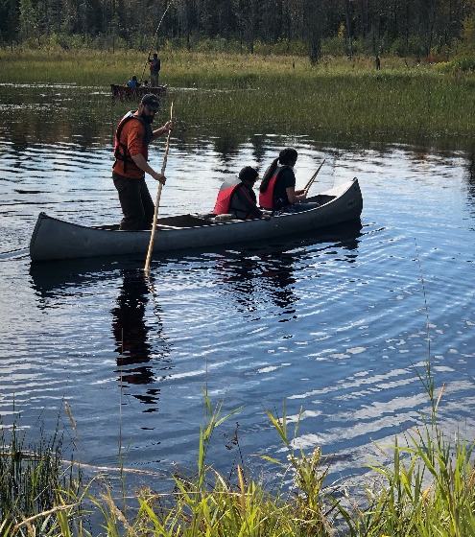
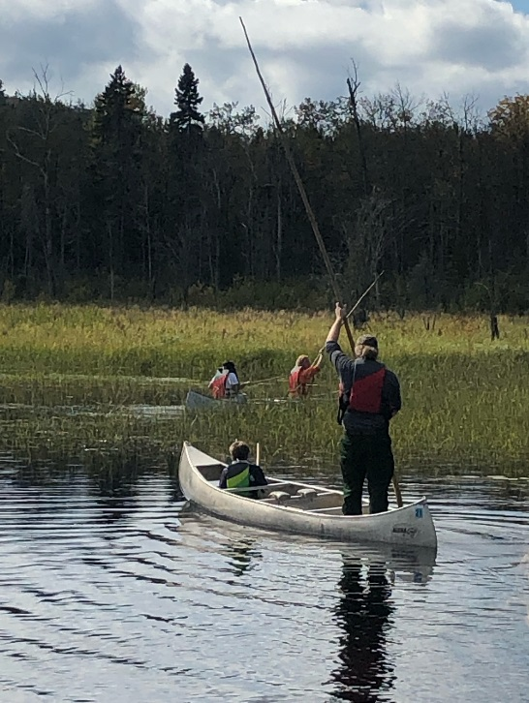
Enjoy your weekend,
Ms. Carmen

Photo Credits to Desi-
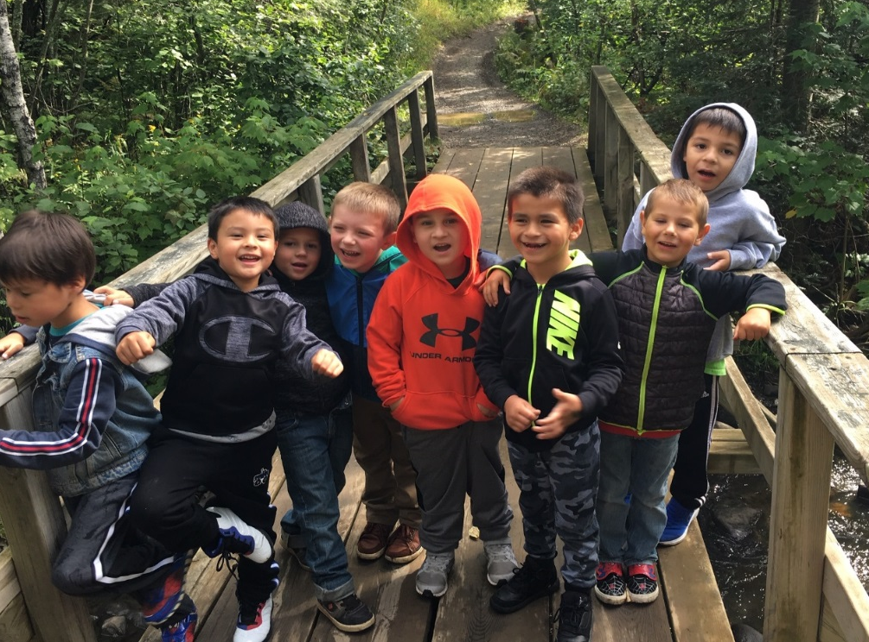
Ms. Jeana- K-2 NEWS
The first week of school, the students were learning the rules of the classroom and the school rules. They did great for their first week. The second week of school the students learned the letter C and O. They learned the sound it makes and how to write it. We are also practicing how to read to self, while building stamina, and learning the front and back of the book. Our monthly reading challenge was also introduced. Students are highly encouraged to read 20 mins per night and get classroom rewards when they meet their goals. The first week of school the students were exploring all the math tools we will be using this year. The second week of school the students have been learning a number a day. They have learned and practiced number sense of 0,1,2,3,4,5,6,7,8, and 9; learning number recognition, how to write it, how to count it and how to make it (ex. With counters, dice, pictures, fingers and dominos). Computers were also introduced for math using the IXL program will continue to use throughout the year. The students have been working on writing their name, practicing the letter C and O, and writing the numbers they have learned. Students have also been practicing using scissor skills and other fine motor activities to help build hand strength. The students are learning how to explore and what that looks like. We practiced exploring and learned how to use boundaries in the classroom, on the playground, and on the ball field. We are also discussing and enforcing the use of statements; I notice, I wonder, and it reminds me of so that we can start using our nature journals at Waaban and science. Ms. Bonita came into our classroom and taught the students the importance of sweet grass. She told us a condensed history and cultural significance, along with a small activity to teach the kindergarteners the proper etiquette while picking sweetgrass. Later that day we walked down to the sweet grass field at the Park Service and the students got to go into the field to see what sweetgrass looks like and smells like in nature. It has been a great start to the school year!

Mr.Brooks 4-6 NEWS
Students are learning about their classroom rules and reviewing school rules. We have talked a lot about how to treat others and how we want to be treated to avoid bullying like behavior. We have needed a lot of reminders about this- parents can also have these discussions to reinforce how to treat others. Students are working on stamina of reading to self, in math working on graphing and number theory. Families can work on math facts at home and play games that require adding, subtracting, multiplication and division. Practicing of math facts is an on- going skill to work on and the better students are at them the easier middle and high school math will be. Reading at home also continues to be something all students should practice, reading 20 minutes every night will help improve reading skills. Students and Mr. Brooks and Ms. Kat are all trying to get to know each other and it has been a great start to the school year!
