February 7, 2020 – Namebini-Giizis( sucker moon)

Volume 8 Issue 9
Oshki Ogimaag 73 Upper Rd, PO Box 320

Upcoming Events
Feb 13 Valentine Party and 100th Day of School
Feb 14 and 17 NO SCHOOL
Feb 18 Storytelling (watch for more details)
Feb 19 School board meeting 4:30 pm
Lunch Menu – February 10-21st, 2020
Monday – Goulash, broccoli, pears
Tuesday - Taco’s, cornbread
Wednesday – Chicken gravy& mashed potatoes
Thursday – Bosco sticks, salad, oranges (lucky tray day)
Friday – NO SCHOOL

Monday – NO SCHOOL
Tuesday – Corndogs, fries,
Wednesday – Hamb gravy & mashed potatoes
Thursday – Pizza, salad, oranges
Friday – Soup & Sandwiches

All meals come with vegetable, fruit, bread & milk
OOCS menu can be found at oshkiogimaag.org

Don’t forget the Ojibwe Language Table
every Monday 5:30-7:00 P.M.
in the Oshki Conference Room.
You can join anytime and learn some of t the Ojibwemowin that our students are
learning. Light refreshments provided and
everyone is welcome!

www.oshkiogimaag.org (218) 475-2112

FYI: Valentine class parties will be February 13th as there is no school for students on the 14th. Class lists went out last week but if you need another please let us know.
We would like to thank the families that have taken the time to fill and return the family surveys; if you haven’t yet returned yours please send it in on Monday. We value your input!
Kindergarten NEWS:
We are almost to 100 days of school and the students are very excited to celebrate their accomplishments. We have started reading to the Elders at the community center and the kids did great on their first time going. We have been reading a chapter book in class and the students are working on finding the setting and characters. They are also asked comprehension questions. Since we have finished the alphabet, the students are starting to learn diagraphs (th, sh, wh, and ch). They are learning two new sight words a week and so far, they have learned 16 new words. At Waaban, the students search in the woods to find something interesting and we use the prompts I wonder, I notice, and it reminds me of to start a conversation. Once we discuss, the students write their responses in their science journal.
Culture Liaison, Bonita Poitra
We have been working on getting more detailed observations for our Winter Count. We have 4 weeks of data that our students are drawing on their winter count hide (paper) from January. We have been using I Notice…, I Wonder... It reminds me... format on observations to add to our Phenology information. The students pick on observation to record. The students draw that observation and create a key that will tell what each picture is. I have also done the full moon art with K-1 on a big Gichi Manidoo Giizis and also taught the phases of the moon, and a lesson on Grandmother Moon. We have worked on several stories. The older students have also been learning about “Why Some Tree’s Keep Their Leaves and Others do Not”, which teaches the virtues of Balsam, White Pine and Cedar have for the Anishinaabe as well as Characteristics of each tree including bark, needles, cones and form. Younger students are learning about animal adaptations in the story Why Fawns Have Spots.

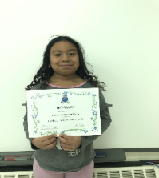
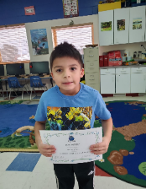
Congratulations Ho-wah! Award winners for January: Uriah Dahl and Cassidy Hendrickson. Each week an Oshki student is recognized for excellence in Ojibwe language: good job Uriah and Cassidy!

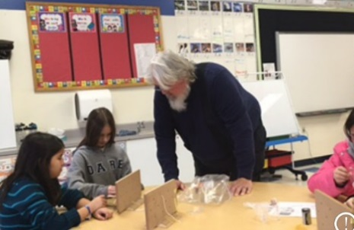
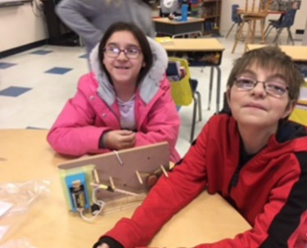
4,5,6 Grade –Mr. Brooks/Ms. Kat
Boozhoo! Well our class has been busy yet enjoyable winter so far! Swimming was a success!! The students enjoyed two weeks of swimming lessons provided by the YMCA. All the students did a great job and their confidence and swimming skills are stronger!
In Science, the students have been learning about hum dingers! They were presented with a device that hums when its string is pulled and dings when the string is released. Working in collaborative groups, they designed and built a physical model of a hum dinger, comparing the performance of the real device to their models. Over several sessions, students observed, designed, tested, compared, and redesigned it until they engineered a successful model that replicated the sounds produced by the hum dinger.

At Waaban, the students learned about the White Pine and the Cedar Tree. Miss Bonita taught them about the different characteristics of each tree and the virtues they share with the Anishinaabe. We have also been putting the snowshoes to a lot of use by packing our trails down and as always, doing what preparations we can for Sugarbush.
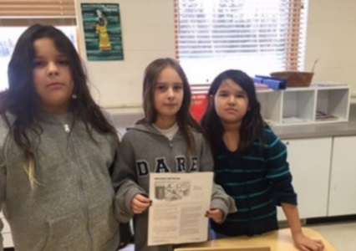
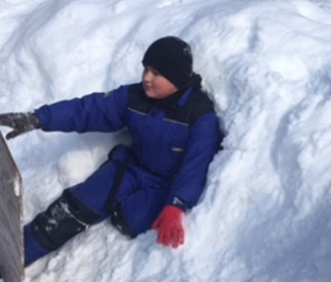
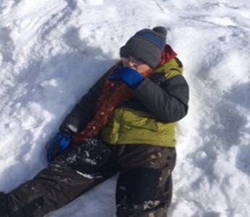
In Social Studies the students have been learning about one of the most important events in Minnesota history, the Dakota War of 1862, also known as the Sioux or Dakota Uprising. This was an armed conflict between the United States and several bands of Dakota Sioux. It began on August 17, 1862 along the Minnesota River in southwest Minnesota and ended with a mass execution of 38 Dakota men December 26, 1862, in Mankato, Minnesota.
Weather Closures: In the event we need to close due to inclement weather or other unforeseen reasons, you will receive a call from our school automated phone service. It will also be posted on Facebook and TV channels 6 and 10. This is one of the many reasons why you need to make sure that we have your current phone number on file here at OOCS.

Warm clothing: Your child should have appropriate winter gear every day! This includes snow pants, boots, hat and mittens!

Absences: If your child will not be at school, YOU need to notify the school. If we do not hear from you, your student will be marked UNEXCUSED.

February 24: The ABCs of the IEP: Making the IEP Work For Your Child FREE This workshop is offered by Cook Co Higher Ed-you should contact them with questions and to sign up.
Hosted and Presented by the Pacer Center
This workshop will help parents understand how to use the Individualized Education Program (IEP) to benefit their child. Participants will use a PACER booklet to understand how each required part of the IEP can be developed to meet the child’s needs. Parents will gain knowledge about how to participate effectively in the annual IEP meeting.

