December 11, 2020 – Manidoo-giizisoons Little Spirit Moon
Volume 9 Issue 7
Oshki Ogimaag 73 Upper Rd, PO Box 320
Grand Portage, MN 55605
475-2112 www.oshkiogimaag.org

Boozhoo Oshki Families!

As we go into December we continue to work very hard at sanitizing everything and making sure everyone has a mask that fits properly and that we social distance. It is our hope that families practice that as well- what happens outside of school impacts us greatly! We want everyone to stay as safe and healthy as possible and we need you to do your part in sanitizing your hands and your families hands, wearing your mask when leaving your house, staying home when you can, avoid crowds and large groups of people, social distance when around people that do not live in your household.

While we are hoping to continue to have in-person learning, we are also preparing ourselves for the possibility of having to go to a distance learning teaching model. As parents you should also be putting thought into what you and your family would need to do if your child's classroom or our entire school needed to close due to covid-19. We do not know if we will have only a one day notice when switching to distance learning or two or more days. Some things to think about as parents of children in elementary school-
Who will watch our students if I have to go to work?
Who will make sure my student is logging in each day to check in with their teacher and get their daily instruction?
Who will help our students do their school work? Or at least make sure our student is doing their school work??

If you are wondering what our Distance Learning style of teaching looks like, please log in to www.oshkiogimaag.org
For those that were enrolled last year, DL will look different this year for your student, so please look at our OOCS PLAN for 2020-21. It will be mandatory for students to be more engaged with their teachers on a daily basis through a Google classroom platform, there will not be a daily drop off of meals and work, instead there will be “Pick Up” days- Parents will be able to pick up meals and any books, paper packets or other items needed twice a week. You will also be able to drop off projects, packets, books, etc at the same time. (These days and times have not yet been determined)

Please feel free to reach out to your students' teacher or Ms. Carmen if you have questions.

More on the back!

TARDY: Please try to limit the amount of occasions that your student comes in late, they miss out on important learning and it interrupts the classroom routine. While we understand mornings can be tricky with youngsters and coming in late is better than not coming at all- We really encourage all students to be to school on time.

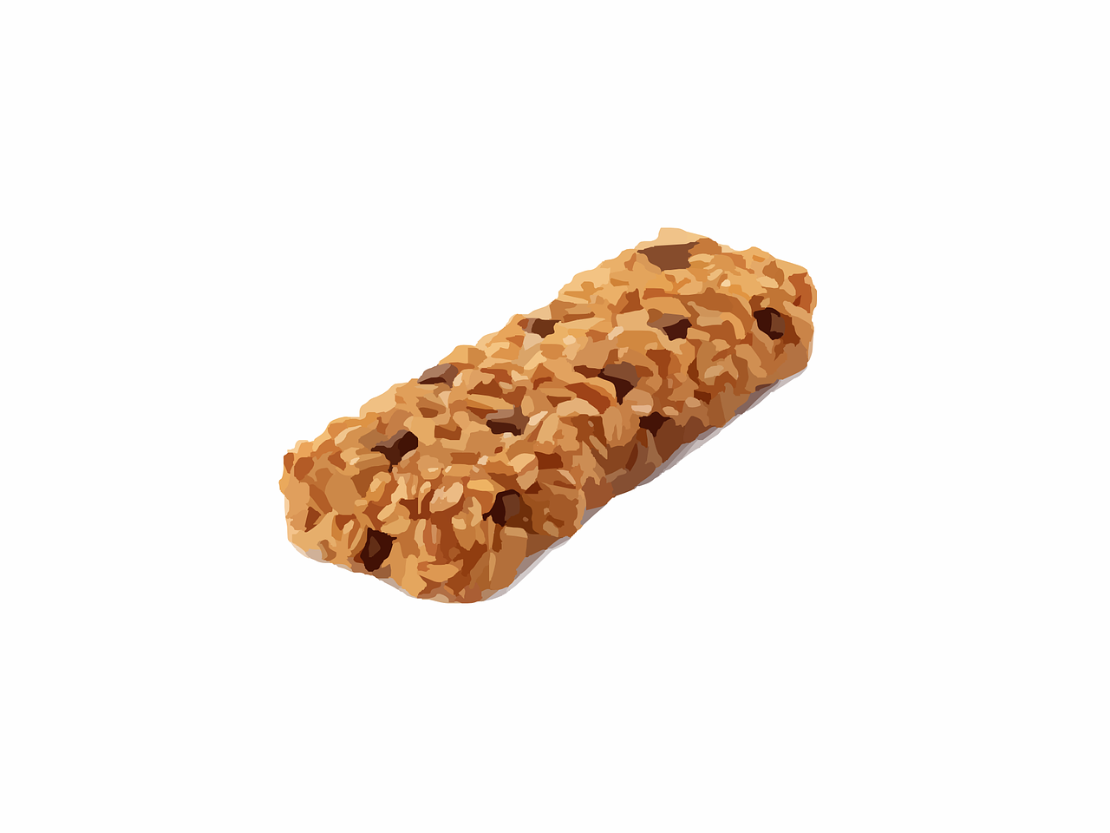
Breakfast is served from 8:00-8:40 For students that come in late we will save breakfast but only until 9:00! Anyone that comes in after 9:00 should ideally eat at home, if they do not eat at home they will be offered a granola bar and milk.

We are planning to have our ANNUAL HOLIDAY PROGRAM
December 17 at 6:00 pm at the Oshki Ogimaag Charter School parking Lot.
Remember to dress warm, wear your mask and stay socially distanced from those that do not live in your household.

The Performance will be held outdoors-in our parking lot.
The students should report to their classrooms at 5:30 -
We will use our steps as ‘risers’; a portion of the parking lot will be blocked off for spectators to stand. All of the students are practicing everyday to learn their songs, they are very excited for the program. I hope the weather cooperates and I hope covid stays away-
I look forward to seeing you on December 17.

