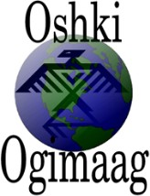

PO Box 320
Grand Portage, MN 55605

2022-23 Oshki Ogimaag Charter School Board Meeting Schedule
All meetings at 4:30 at OOCS unless otherwise stated.

August 17, 2022
September 21, 2022
October 19, 2022
November 16, 2022

December 14, 2022 @ 6:00 pm Annual Meeting

January 18, 2023
February 15, 2023
March 15, 2023
April 19, 2023
May 17, 2023
June 21, 2023

